**VISVESVARAYA TECHNOLOGICAL UNIVERSITY**

**“JnanaSangama”, Belgaum -590014, Karnataka.**



**LAB REPORT**

**on**

**MACHINE LEARNING**

**(20CS6PCMAL)**

***Submitted by***

**SOHAN R KUMAR (1BM19CS159)**

***in partial fulfillment for the award of the degree of***

**BACHELOR OF ENGINEERING**

***in***

**COMPUTER SCIENCE AND ENGINEERING**



**B.M.S. COLLEGE OF ENGINEERING**

**(Autonomous Institution under VTU)**

**BENGALURU-560019**

**May-2022 to July-2022**

**B. M. S. College of Engineering,**

**Bull Temple Road, Bangalore 560019**

(Affiliated To Visvesvaraya Technological University, Belgaum)

**Department of Computer Science and Engineering**



**CERTIFICATE**

This is to certify that the Lab work entitled “**MACHINE LEARNING**” was carried out by **SOHAN R KUMAR (1BM19CS159),** who is a bona fide student of **B. M. S. College of Engineering.** It is in partial fulfillment for the award of **Bachelor of Engineering in Computer Science and Engineering** of the Visvesvaraya Technological University, Belgaum during the year 2022. The Lab report has been approved as it satisfies the academic requirements in respect of the course **MACHINE LEARNING (20CS6PCMAL)** work prescribed for the said degree.

Name of the Lab-In charge               **DR. ASHA G R**

Designation Assistant Professor

Department of CSE Department of CSE

BMSCE, Bengaluru BMSCE, Bengaluru

`

**Index Sheet**

|  |  |  |
| --- | --- | --- |
| **Sl. No.** | **Experiment Title** | **Page No.** |
| **1.** | **FIND-S :-** Implement and demonstrate the FIND-S algorithm for finding the most specific hypothesis based on a given set of training data samples. | **5** |
| **2.** | **CANDIDATE ELIMINATION :-** For a given set of training data examples stored in a .CSV file, implement and demonstrate the Candidate-Elimination algorithm to output a description of the set of all hypotheses consistent with the training examples. | **11** |
| **3.** | **ID3 :-** Write a program to demonstrate the working of the decision tree based ID3 algorithm. Use an appropriate data set for building the decision tree and apply this knowledge to classify a new sample. | **20** |
| **4.a.** | **NAÏVE BAYESIAN CLASSIFIER** :- Write a program to implement the naïve Bayesian classifier for a sample training data set stored as a .CSV file. Compute the accuracy of the classifier, considering few test data sets | **31** |
| **4.b.** | **NAÏVE BAYESIAN CLASSIFIER (Without packages) :-** Write a program to implement the naïve Bayesian classifier for a sample training data set stored as a .CSV file. Compute the accuracy of the classifier, considering few test data sets.(Without packages) | **40** |
| **5.** | **LINEAR REGRESSION :-** Implement the Linear Regression algorithm in order to fit data points. Select appropriate data set for your experiment and draw graphs. | **55** |
| **6.** | **BAYESIAN NETWORK :-**Write a program to construct a Bayesian network considering training data. Use this model to make predictions. | **62** |
| **7.** | **K-MEANS :-**Apply k-Means algorithm to cluster a set of data stored in a .CSV file. | **76** |
| **8.** | **EM :-**Apply EM algorithm to cluster a set of data stored in a .CSV file. Compare the results of k-Means algorithm and EM algorithm. | **84** |
| **9.** | **K NEAREST NEIGHBOUR :-**Write a program to implement k-Nearest Neighbor algorithm to classify the iris data set. Print both correct and wrong predictions. | **90** |
| **10.** | **LOCALLY WEIGHTED REGRESSION :-**Implement the non-parametric Locally Weighted Regression algorithm in order to fit data points. Select appropriate data set for your experiment and draw graphs. | **101** |

**Course Outcome :-**

***At the end of the course the student will be able to***

|  |  |
| --- | --- |
| CO1 | Ability to apply the different learning algorithms. |
| CO2 | Ability to analyze the learning techniques for given dataset. |
| CO3 | Ability to design a model using machine learning to solve a problem. |
| CO4 | Ability to conduct practical experiments to solve problems using appropriate machine learning techniques. |

**Lab Program -1 :-**

Implement and demonstrate the FIND-S algorithm for finding the most specific hypothesis based on a given set of training data samples.

***Source code and output :-***

+*In[1]:*+

[source, ipython3]

----

import csv

hypo = ['%','%','%','%','%','%'];

with open(r'C:\Users\Admin\OneDrive\Desktop\6th sem\ML\lab-ml\lab 1\finds.csv') as csv_file:

readcsv = csv.reader(csv_file, delimiter=',')

print(readcsv)

data = []

print("\nThe given training examples are:")

for row in readcsv:

print(row)

if row[len(row)-1].upper() == "YES":

data.append(row)

----

+*Out[1]:*+

----

<_csv.reader object at 0x0000013B7E4DFD60>

The given training examples are:

['sky', 'air temp', 'humidity', 'wind', 'water', 'forecast', 'enjoy sport']

['sunny', 'warm', 'normal', 'strong', 'warm', 'same', 'yes']

['sunny', 'warm', 'high', 'strong', 'warm', 'same', 'yes']

['rainy', 'cold', 'high', 'strong', 'warm', 'change', 'no']

['sunny', 'warm', 'high', 'strong', 'cool', 'change', 'yes']

----

+*In[2]:*+

[source, ipython3]

----

print("\nThe positive examples are:");

for x in data:

print(x);

print("\n");

----

+*Out[2]:*+

----

The positive examples are:

['sunny', 'warm', 'normal', 'strong', 'warm', 'same', 'yes']

['sunny', 'warm', 'high', 'strong', 'warm', 'same', 'yes']

['sunny', 'warm', 'high', 'strong', 'cool', 'change', 'yes']

----

+*In[3]:*+

[source, ipython3]

----

TotalExamples = len(data);

i=0;

j=0;

k=0;

print("The steps of the Find-s algorithm are :\n",hypo);

list = [];

p=0;

d=len(data[p])-1;

for j in range(d):

list.append(data[i][j]);

hypo=list;

i=1;

for i in range(TotalExamples):

for k in range(d):

if hypo[k]!=data[i][k]:

hypo[k]='?';

k=k+1;

else:

hypo[k];

print(hypo);

i=i+1;

----

+*Out[3]:*+

----

The steps of the Find-s algorithm are :

['%', '%', '%', '%', '%', '%']

['sunny', 'warm', 'normal', 'strong', 'warm', 'same']

['sunny', 'warm', '?', 'strong', 'warm', 'same']

['sunny', 'warm', '?', 'strong', '?', '?']

----

+*In[4]:*+

[source, ipython3]

----

print("\nThe maximally specific Find-s hypothesis for the given training examples is :");

list=[];

for i in range(d):

list.append(hypo[i]);

print(list);

----

+*Out[4]:*+

----

The maximally specific Find-s hypothesis for the given training examples is :

['sunny', 'warm', '?', 'strong', '?', '?']

----

+*In[ ]:*+

[source, ipython3]

----

----

***Output screenshots :-***

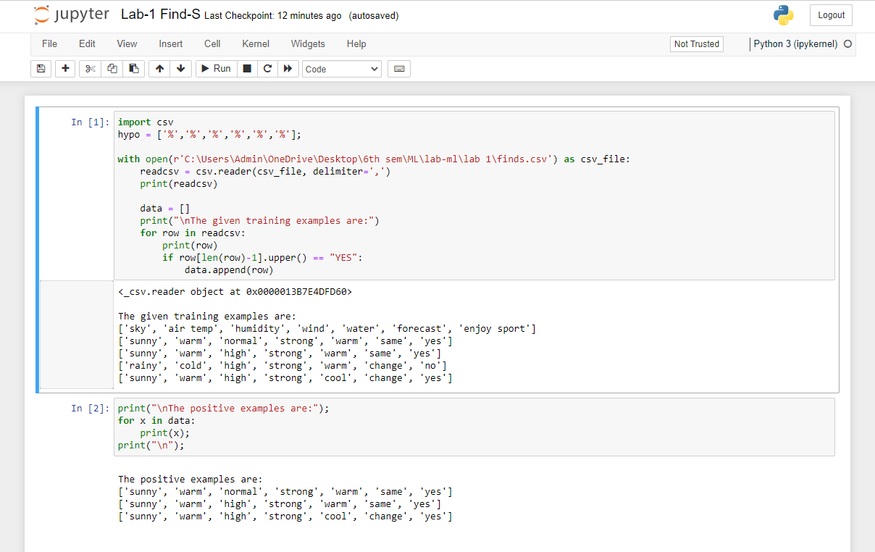

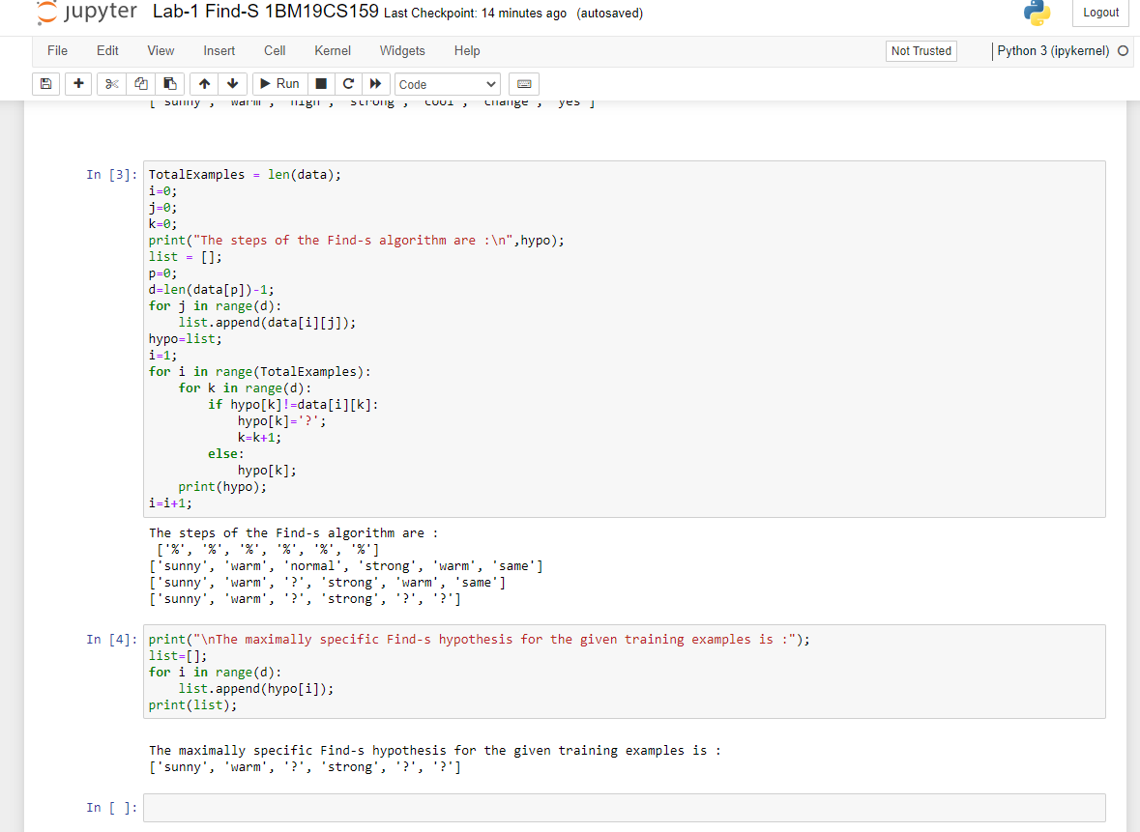

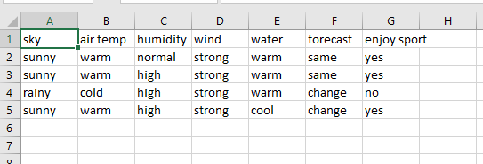

**Lab Program -2 :-**

For a given set of training data examples stored in a .CSV file, implement and demonstrate the Candidate-Elimination algorithm to output a description of the set of all hypotheses consistent with the training examples.

***Source code and output :-***

+*In[7]:*+

[source, ipython3]

----

import numpy as np

import pandas as pd

----

+*In[10]:*+

[source, ipython3]

----

# Loading Data from a CSV File

data = pd.DataFrame(data=pd.read_csv(r'C:\Users\Admin\OneDrive\Desktop\6th sem\ML\lab-ml\lab 2\trainingdata.csv'))

print(data)

----

+*Out[10]:*+

----

sky airtemp humidity wind water forecast enjoySport

0 Sunny Warm Normal Strong Warm Same Yes

1 Sunny Warm High Strong Warm Same Yes

2 Rainy Cold High Strong Warm Change No

3 Sunny Warm High Strong Cool Change Yes

----

+*In[11]:*+

[source, ipython3]

----

# Separating concept features from Target

concepts = np.array(data.iloc[:,0:-1])

print(concepts)

----

+*Out[11]:*+

----

[['Sunny' 'Warm' 'Normal' 'Strong' 'Warm' 'Same']

['Sunny' 'Warm' 'High' 'Strong' 'Warm' 'Same']

['Rainy' 'Cold' 'High' 'Strong' 'Warm' 'Change']

['Sunny' 'Warm' 'High' 'Strong' 'Cool' 'Change']]

----

+*In[12]:*+

[source, ipython3]

----

# Isolating target into a separate DataFrame

# copying last column to target array

target = np.array(data.iloc[:,-1])

print(target)

----

+*Out[12]:*+

----

['Yes' 'Yes' 'No' 'Yes']

----

+*In[13]:*+

[source, ipython3]

----

def learn(concepts, target):

'''

learn() function implements the learning method of the Candidate elimination algorithm.

Arguments:

concepts - a data frame with all the features

target - a data frame with corresponding output values

'''

# Initialise S0 with the first instance from concepts

# .copy() makes sure a new list is created instead of just pointing to the same memory location

specific_h = concepts[0].copy()

print("\nInitialization of specific_h and general_h")

print(specific_h)

#h=["#" for i in range(0,5)]

#print(h)

general_h = [["?" for i in range(len(specific_h))] for i in range(len(specific_h))]

print(general_h)

# The learning iterations

for i, h in enumerate(concepts):

# Checking if the hypothesis has a positive target

if target[i] == "Yes":

for x in range(len(specific_h)):

# Change values in S & G only if values change

if h[x] != specific_h[x]:

specific_h[x] = '?'

general_h[x][x] = '?'

# Checking if the hypothesis has a positive target

if target[i] == "No":

for x in range(len(specific_h)):

# For negative hyposthesis change values only in G

if h[x] != specific_h[x]:

general_h[x][x] = specific_h[x]

else:

general_h[x][x] = '?'

print("\nSteps of Candidate Elimination Algorithm",i+1)

print(specific_h)

print(general_h)

# find indices where we have empty rows, meaning those that are unchanged

indices = [i for i, val in enumerate(general_h) if val == ['?', '?', '?', '?', '?', '?']]

for i in indices:

# remove those rows from general_h

general_h.remove(['?', '?', '?', '?', '?', '?'])

# Return final values

return specific_h, general_h

----

+*In[14]:*+

[source, ipython3]

----

s_final, g_final = learn(concepts, target)

print("\nFinal Specific_h:", s_final, sep="\n")

print("\nFinal General_h:", g_final, sep="\n")

----

+*Out[14]:*+

----

Initialization of specific_h and general_h

['Sunny' 'Warm' 'Normal' 'Strong' 'Warm' 'Same']

[['?', '?', '?', '?', '?', '?'], ['?', '?', '?', '?', '?', '?'], ['?', '?', '?', '?', '?', '?'], ['?', '?', '?', '?', '?', '?'], ['?', '?', '?', '?', '?', '?'], ['?', '?', '?', '?', '?', '?']]

Steps of Candidate Elimination Algorithm 1

['Sunny' 'Warm' 'Normal' 'Strong' 'Warm' 'Same']

[['?', '?', '?', '?', '?', '?'], ['?', '?', '?', '?', '?', '?'], ['?', '?', '?', '?', '?', '?'], ['?', '?', '?', '?', '?', '?'], ['?', '?', '?', '?', '?', '?'], ['?', '?', '?', '?', '?', '?']]

Steps of Candidate Elimination Algorithm 2

['Sunny' 'Warm' '?' 'Strong' 'Warm' 'Same']

[['?', '?', '?', '?', '?', '?'], ['?', '?', '?', '?', '?', '?'], ['?', '?', '?', '?', '?', '?'], ['?', '?', '?', '?', '?', '?'], ['?', '?', '?', '?', '?', '?'], ['?', '?', '?', '?', '?', '?']]

Steps of Candidate Elimination Algorithm 3

['Sunny' 'Warm' '?' 'Strong' 'Warm' 'Same']

[['Sunny', '?', '?', '?', '?', '?'], ['?', 'Warm', '?', '?', '?', '?'], ['?', '?', '?', '?', '?', '?'], ['?', '?', '?', '?', '?', '?'], ['?', '?', '?', '?', '?', '?'], ['?', '?', '?', '?', '?', 'Same']]

Steps of Candidate Elimination Algorithm 4

['Sunny' 'Warm' '?' 'Strong' '?' '?']

[['Sunny', '?', '?', '?', '?', '?'], ['?', 'Warm', '?', '?', '?', '?'], ['?', '?', '?', '?', '?', '?'], ['?', '?', '?', '?', '?', '?'], ['?', '?', '?', '?', '?', '?'], ['?', '?', '?', '?', '?', '?']]

Final Specific_h:

['Sunny' 'Warm' '?' 'Strong' '?' '?']

Final General_h:

[['Sunny', '?', '?', '?', '?', '?'], ['?', 'Warm', '?', '?', '?', '?']]

----

+*In[ ]:*+

[source, ipython3]

----

----

***Output screenshots :-***

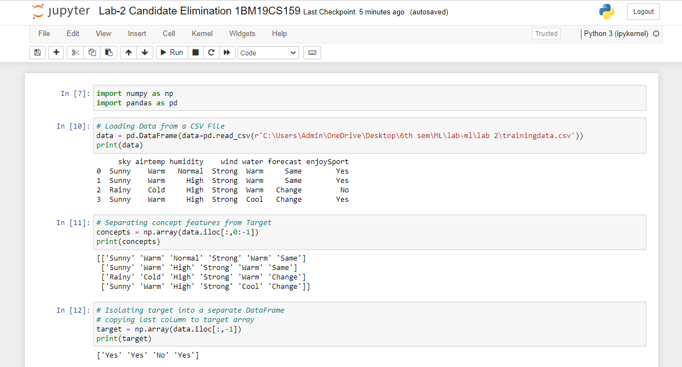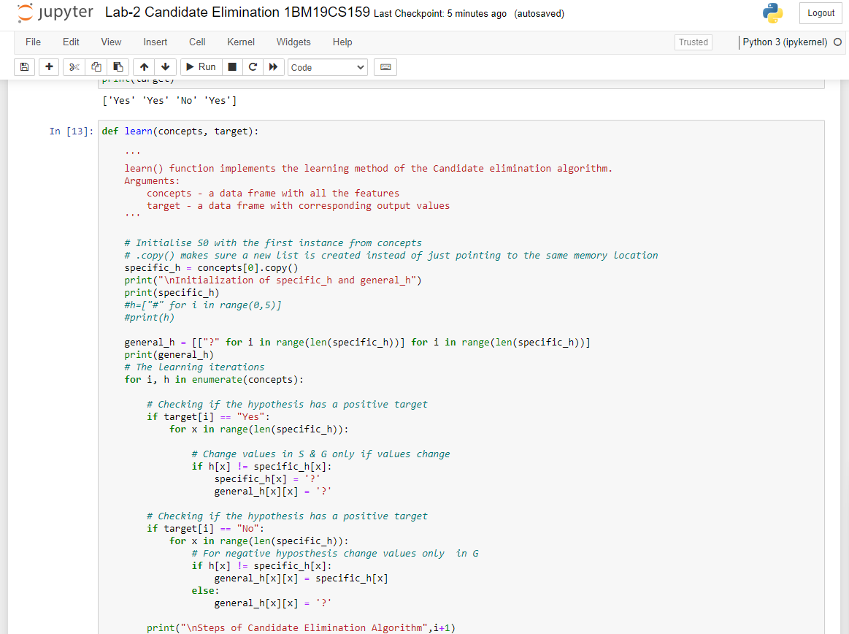

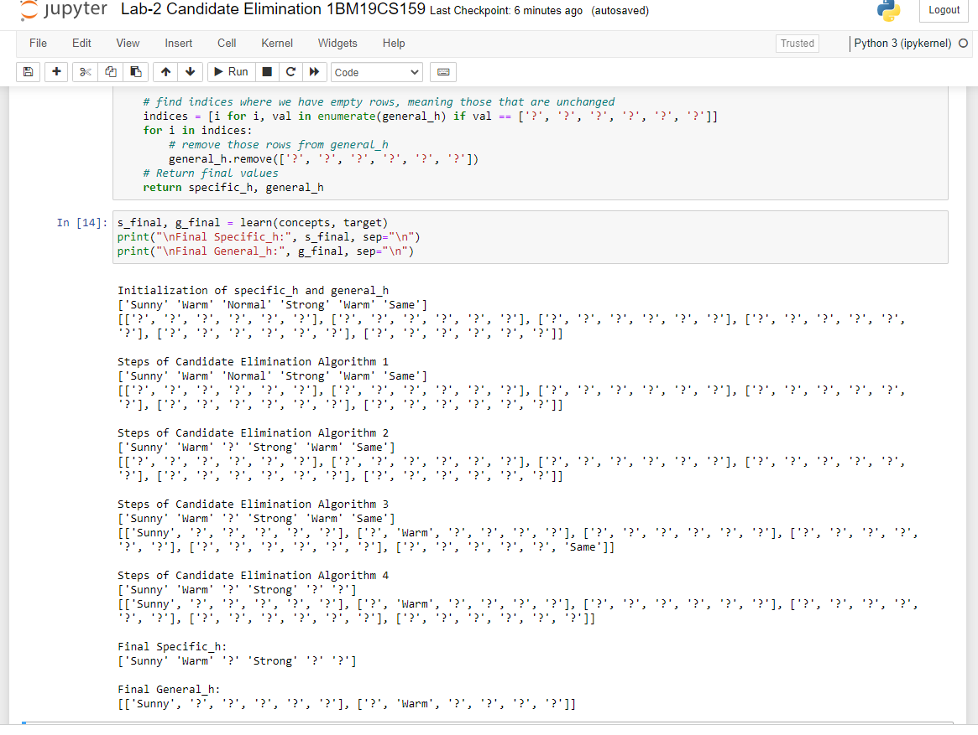

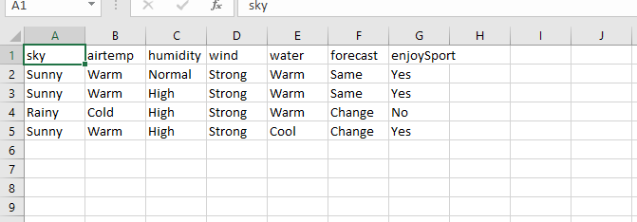

**Lab Program -3 :-**

Write a program to demonstrate the working of the decision tree based ID3 algorithm. Use an appropriate data set for building the decision tree and apply this knowledge to classify a new sample.

***Source code and output :-***

+*In[1]:*+

[source, ipython3]

----

import numpy as np

import math

import csv

----

+*In[2]:*+

[source, ipython3]

----

def read_data(filename):

with open(filename, 'r') as csvfile:

datareader = csv.reader(csvfile, delimiter=',')

headers = next(datareader)

metadata = []

traindata = []

for name in headers:

metadata.append(name)

for row in datareader:

traindata.append(row)

return (metadata, traindata)

----

+*In[5]:*+

[source, ipython3]

----

class Node:

def __init__(self, attribute):

self.attribute = attribute

self.children = []

self.answer = ""

def __str__(self):

return self.attribute

----

+*In[6]:*+

[source, ipython3]

----

def subtables(data, col, delete):

dict = {}

items = np.unique(data[:, col])

count = np.zeros((items.shape[0], 1), dtype=np.int32)

for x in range(items.shape[0]):

for y in range(data.shape[0]):

if data[y, col] == items[x]:

count[x] += 1

for x in range(items.shape[0]):

dict[items[x]] = np.empty((int(count[x]), data.shape[1]), dtype="|S32")

pos = 0

for y in range(data.shape[0]):

if data[y, col] == items[x]:

dict[items[x]][pos] = data[y]

pos += 1

if delete:

dict[items[x]] = np.delete(dict[items[x]], col, 1)

return items, dict

----

+*In[7]:*+

[source, ipython3]

----

def entropy(S):

items = np.unique(S)

if items.size == 1:

return 0

counts = np.zeros((items.shape[0], 1))

sums = 0

for x in range(items.shape[0]):

counts[x] = sum(S == items[x]) / (S.size * 1.0)

for count in counts:

sums += -1 * count * math.log(count, 2)

return sums

----

+*In[8]:*+

[source, ipython3]

----

def gain_ratio(data, col):

items, dict = subtables(data, col, delete=False)

total_size = data.shape[0]

entropies = np.zeros((items.shape[0], 1))

intrinsic = np.zeros((items.shape[0], 1))

for x in range(items.shape[0]):

ratio = dict[items[x]].shape[0]/(total_size * 1.0)

entropies[x] = ratio * entropy(dict[items[x]][:, -1])

intrinsic[x] = ratio * math.log(ratio, 2)

total_entropy = entropy(data[:, -1])

iv = -1 * sum(intrinsic)

for x in range(entropies.shape[0]):

total_entropy -= entropies[x]

return total_entropy / iv

----

+*In[9]:*+

[source, ipython3]

----

def create_node(data, metadata):

if (np.unique(data[:, -1])).shape[0] == 1:

node = Node("")

node.answer = np.unique(data[:, -1])[0]

return node

gains = np.zeros((data.shape[1] - 1, 1))

for col in range(data.shape[1] - 1):

gains[col] = gain_ratio(data, col)

split = np.argmax(gains)

node = Node(metadata[split])

metadata = np.delete(metadata, split, 0)

items, dict = subtables(data, split, delete=True)

for x in range(items.shape[0]):

child = create_node(dict[items[x]], metadata)

node.children.append((items[x], child))

return node

----

+*In[10]:*+

[source, ipython3]

----

def empty(size):

s = ""

for x in range(size):

s += " "

return s

def print_tree(node, level):

if node.answer != "":

print(empty(level), node.answer)

return

print(empty(level), node.attribute)

for value, n in node.children:

print(empty(level + 1), value)

print_tree(n, level + 2)

----

+*In[11]:*+

[source, ipython3]

----

metadata, traindata = read_data(r"C:\Users\Admin\OneDrive\Desktop\6th sem\ML\lab-ml\Lab 3\id3 training dataset.csv")

data = np.array(traindata)

node = create_node(data, metadata)

print_tree(node, 0)

----

+*Out[11]:*+

----

Outlook

overcast

b'yes'

rain

Wind

b'strong'

b'no'

b'weak'

b'yes'

sunny

Humidity

b'high'

b'no'

b'normal'

b'yes'

----

+*In[ ]:*+

[source, ipython3]

----

----

***Output screenshots :-***

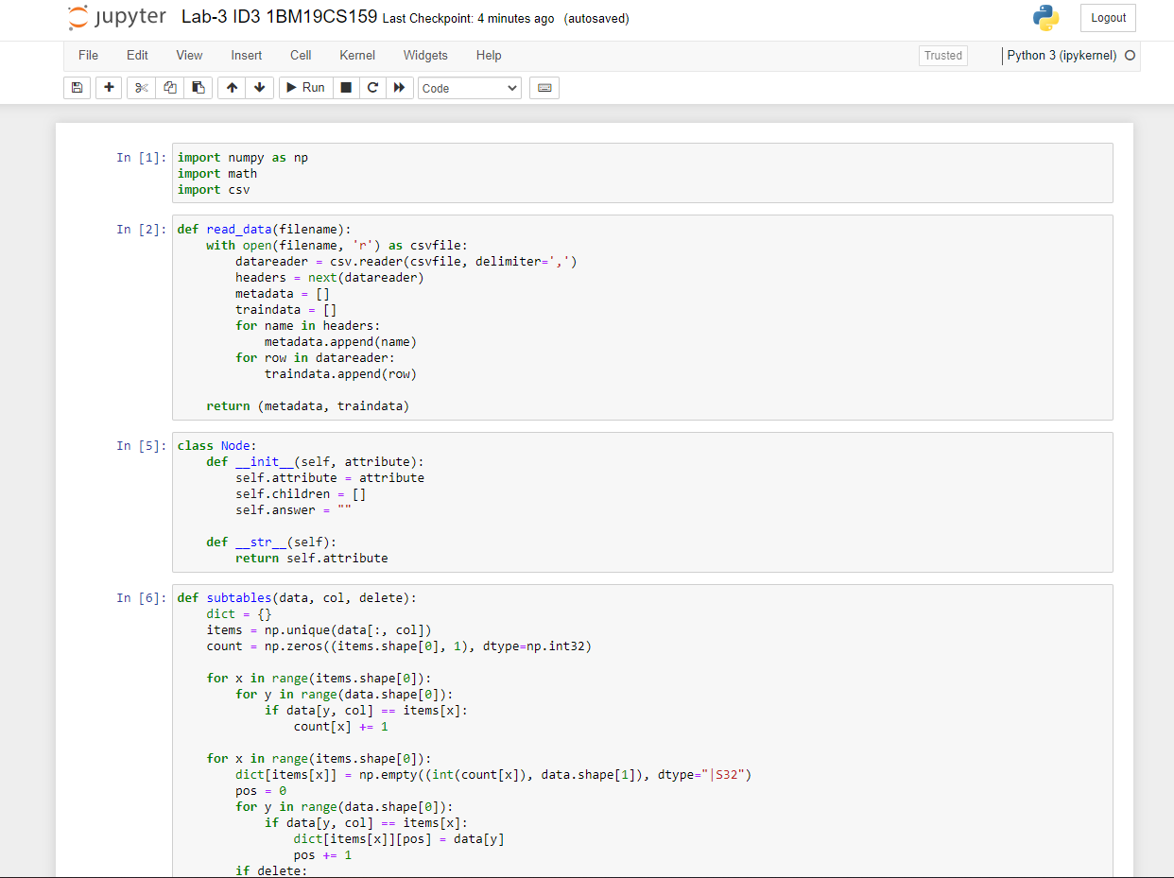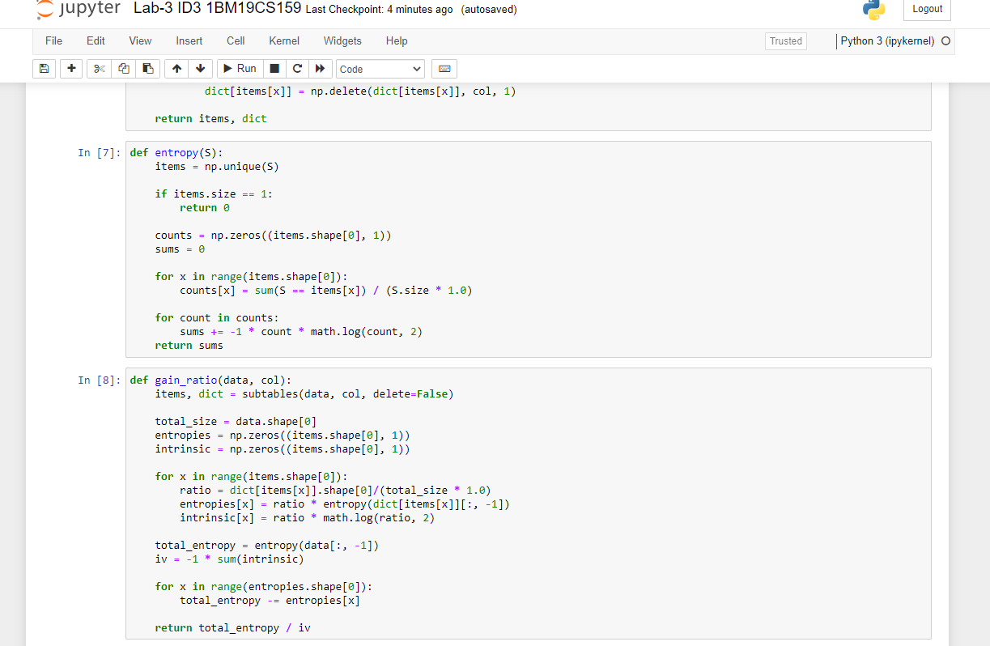

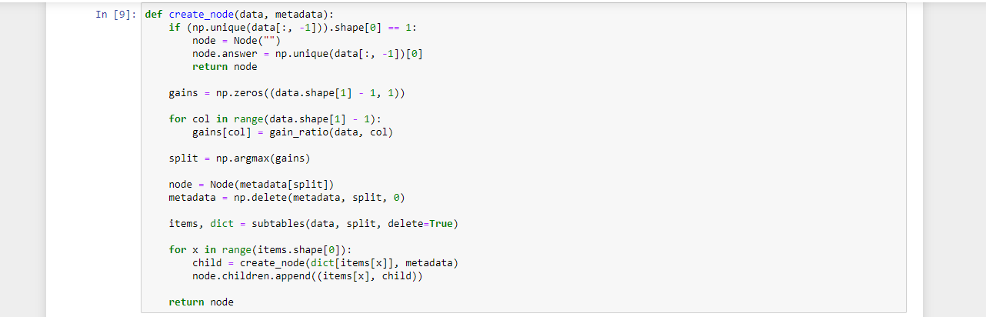 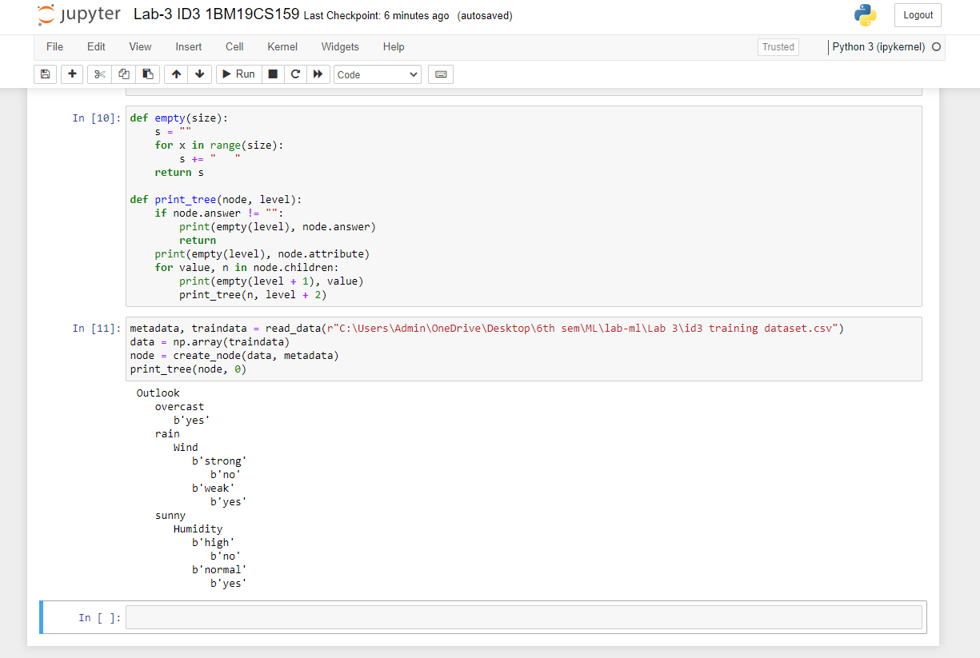 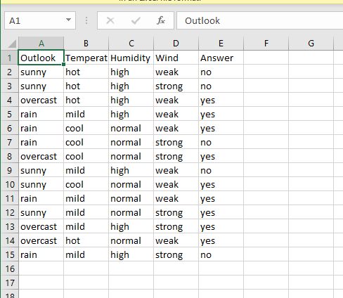

**Lab Program -4.a.:-**

Write a program to implement the naïve Bayesian classifier for a sample training data set stored as a .CSV file. Compute the accuracy of the classifier, considering few test data sets

***Source code and output :-***

+*In[1]:*+

[source, ipython3]

----

# import necessary libarities

import pandas as pd

from sklearn import tree

from sklearn.preprocessing import LabelEncoder

from sklearn.naive_bayes import GaussianNB

# load data from CSV

data = pd.read_csv(r"C:\Users\Admin\OneDrive\Desktop\6th sem\ML\lab-ml\Lab 4\Naive Bayesian classifier training dataset.csv")

print("THe first 5 values of data is :\n",data.head())

----

+*Out[1]:*+

----

THe first 5 values of data is :

Outlook Temperature Humidity Windy PlayTennis

0 Sunny Hot High False No

1 Sunny Hot High True No

2 Overcast Hot High False Yes

3 Rainy Mild High False Yes

4 Rainy Cool Normal False Yes

----

+*In[2]:*+

[source, ipython3]

----

# obtain Train data and Train output

X = data.iloc[:,:-1]

print("\nThe First 5 values of train data is\n",X.head())

----

+*Out[2]:*+

----

The First 5 values of train data is

Outlook Temperature Humidity Windy

0 Sunny Hot High False

1 Sunny Hot High True

2 Overcast Hot High False

3 Rainy Mild High False

4 Rainy Cool Normal False

----

+*In[3]:*+

[source, ipython3]

----

y = data.iloc[:,-1]

print("\nThe first 5 values of Train output is\n",y.head())

----

+*Out[3]:*+

----

The first 5 values of Train output is

0 No

1 No

2 Yes

3 Yes

4 Yes

Name: PlayTennis, dtype: object

----

+*In[4]:*+

[source, ipython3]

----

# Convert then in numbers

le_outlook = LabelEncoder()

X.Outlook = le_outlook.fit_transform(X.Outlook)

le_Temperature = LabelEncoder()

X.Temperature = le_Temperature.fit_transform(X.Temperature)

le_Humidity = LabelEncoder()

X.Humidity = le_Humidity.fit_transform(X.Humidity)

le_Windy = LabelEncoder()

X.Windy = le_Windy.fit_transform(X.Windy)

print("\nNow the Train data is :\n",X.head())

----

+*Out[4]:*+

----

Now the Train data is :

Outlook Temperature Humidity Windy

0 2 1 0 0

1 2 1 0 1

2 0 1 0 0

3 1 2 0 0

4 1 0 1 0

----

+*In[5]:*+

[source, ipython3]

----

le_PlayTennis = LabelEncoder()

y = le_PlayTennis.fit_transform(y)

print("\nNow the Train output is\n",y)

----

+*Out[5]:*+

----

Now the Train output is

[0 0 1 1 1 0 1 0 1 1 1 1 1 0]

----

+*In[6]:*+

[source, ipython3]

----

from sklearn.model_selection import train_test_split

X_train, X_test, y_train, y_test = train_test_split(X,y, test_size=0.20)

classifier = GaussianNB()

classifier.fit(X_train,y_train)

from sklearn.metrics import accuracy_score

print("Accuracy is:",accuracy_score(classifier.predict(X_test),y_test))

----

+*Out[6]:*+

----

Accuracy is: 0.3333333333333333

----

+*In[ ]:*+

[source, ipython3]

----

----

***Output screenshots :-***

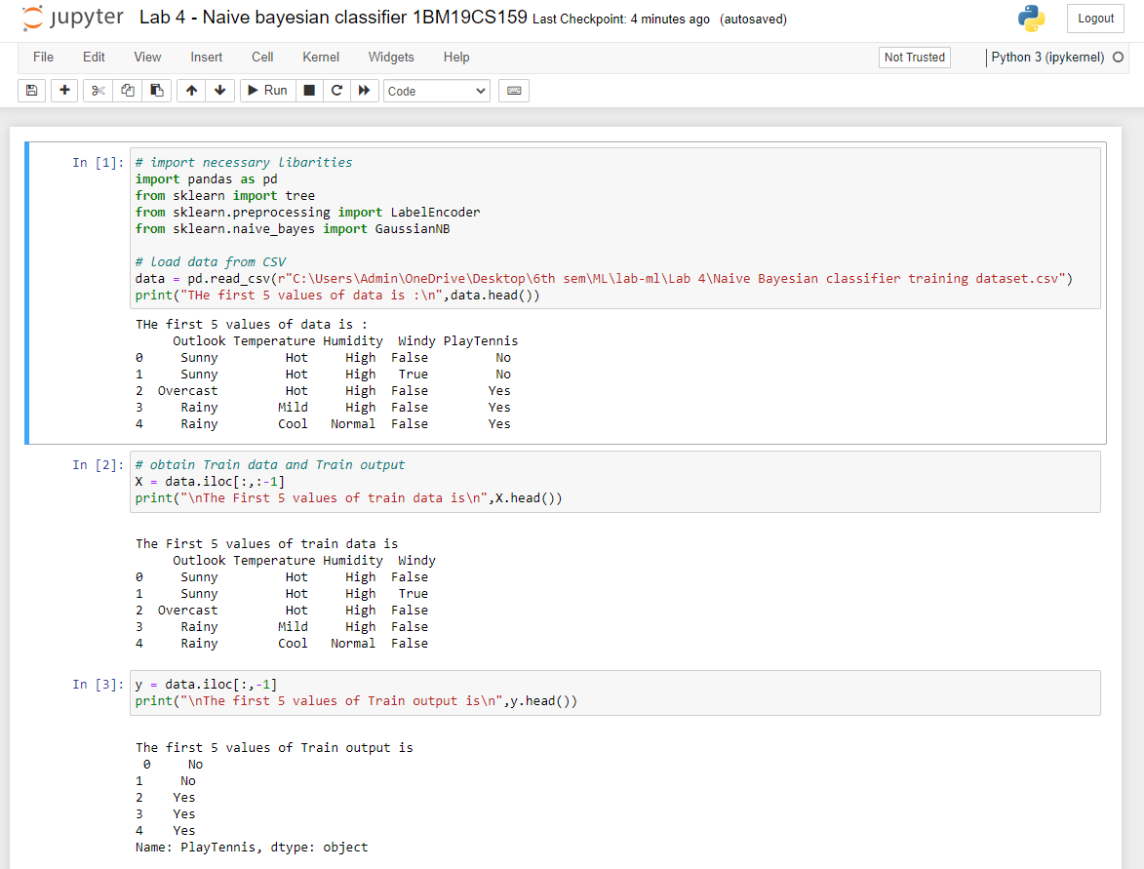

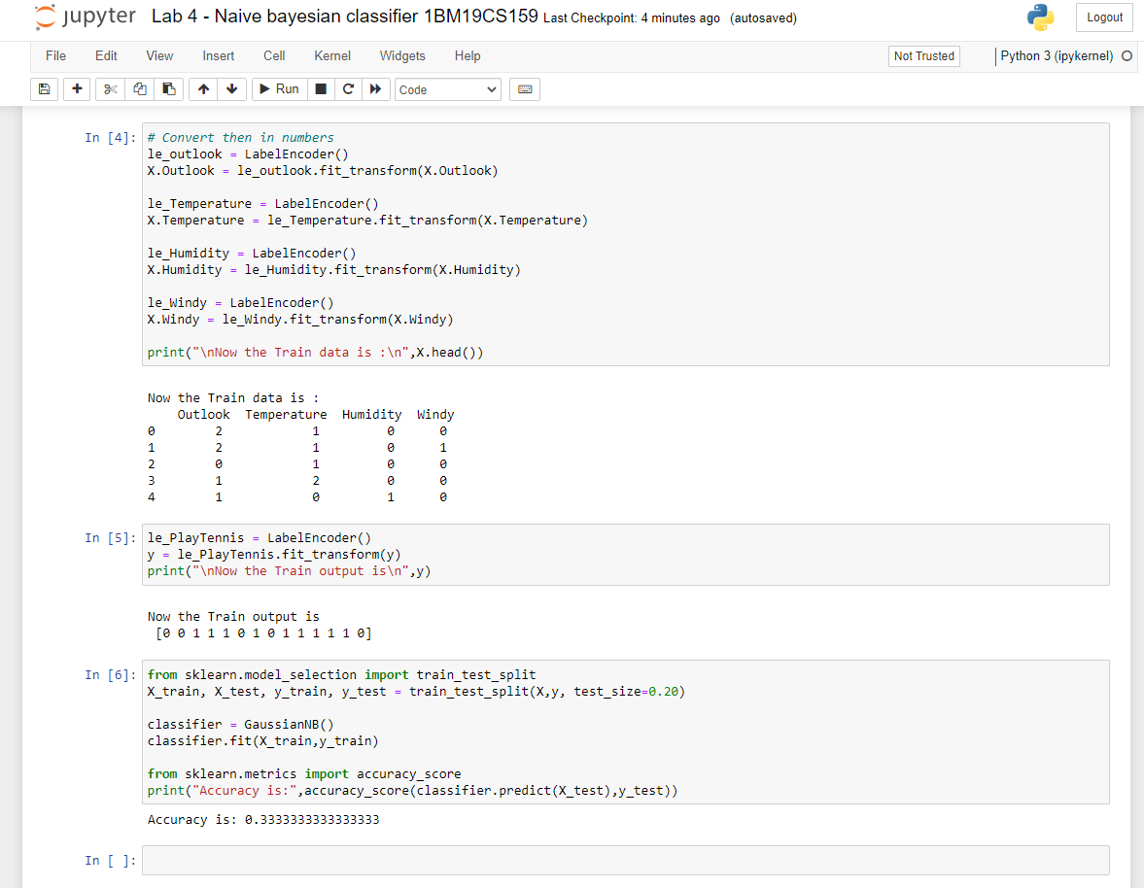

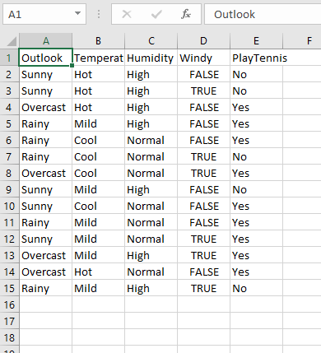

**Lab Program -4.b.:-**

Write a program to implement the naïve Bayesian classifier for a sample training data set stored as a .CSV file. Compute the accuracy of the classifier, considering few test data sets (without packages).

***Source code and output :-***

+*In[1]:*+

[source, ipython3]

----

import math

import csv

import random

----

+*In[2]:*+

[source, ipython3]

----

# This make sures that the dataset is in an ordered format. If we have some arbirary names in that column it difficult to deal with that.

def encode_class(dataset):

classes=[]

for i in range(len(dataset)):

if dataset[i][-1] not in classes:

classes.append(dataset[i][-1])

# Looping across the classes which we have derived above.This will make sure that we have definitive classes (numeric) and not arbitrary

for i in range(len(classes)):

# Looping across all rows of dataset

for j in range(len(dataset)):

if dataset[j][-1] == classes[i]:

dataset[j][-1]=i

return dataset

----

+*In[3]:*+

[source, ipython3]

----

# Splitting the data between training set and testing set. Normally its a general understanding the training:testing=7:3

def train_test_split(dataset,ratio):

test_num=int(ratio*len(dataset))

train=list(dataset)

test=[]

for i in range(test_num):

rand=random.randrange(len(train))

test.append(train.pop(rand))

return train,test

----

+*In[4]:*+

[source, ipython3]

----

# Now depending on resultant value (last column values), we need to group the rows. It will be usefult for calculating mean and std_dev

def groupUnderClass(train):

dict={}

for row in train:

if row[-1] not in dict:

dict[row[-1]]=[]

dict[row[-1]].append(row)

return dict

----

+*In[5]:*+

[source, ipython3]

----

# Standard formulae (just by-heart)

def mean(val):

return sum(val)/float(len(val)) #Obvious

def stdDev(val):

avg=mean(val)

variance=sum([pow(x-avg,2) for x in val])/float(len(val)-1) # Especially this one

return math.sqrt(variance)

----

+*In[6]:*+

[source, ipython3]

----

# We will calculte the mean and std dev with respect to each attribute. Important while calculating gaussian probablity

def meanStdDev(instances):

info=[(mean(x),stdDev(x)) for x in zip(*instances)] # Here we are taking complete column's values of all instances.

del info[-1]

return info

----

+*In[7]:*+

[source, ipython3]

----

# As explained earlier why e need to group. We will be calculating the mean and std dev with respect each class.

def MeanAndStdDevForClass(train):

info={}

dictionary=groupUnderClass(train)

# print(dictionary)

for key,value in dictionary.items():

# dictionary[key]=meanStdDev(value)

info[key]=meanStdDev(value) #Here value stands for a complete group.

return info

----

+*In[8]:*+

[source, ipython3]

----

# Its a formula by heart (no choice)

def calculateGaussianProbablity(x,mean,std_dev):

expo = math.exp(-(math.pow(x - mean, 2) / (2 * math.pow(std_dev, 2))))

return (1 / (math.sqrt(2 * math.pi) * std_dev)) * expo

----

+*In[9]:*+

[source, ipython3]

----

# After calculating mean and std dev w.r.t training data now its time to check if the logic will work on testing data

def calculateClassProbablities(info,ele):

probablities={}

for key,summaries in info.items(): # Info contains the groupName (key) and list of (mean,std_dev) for each attribute of that group

probablities[key]=1

for i in range(len(summaries)): #Loop across all attributes

mean,std_dev=summaries[i]

x=ele[i] # Testing data's one instance's attribute value.

probablities[key] *= calculateGaussianProbablity(x, mean, std_dev)

return probablities

----

+*In[10]:*+

[source, ipython3]

----

def predict(info,ele):

probablities=calculateClassProbablities(info,ele) # returns a dictionary of probablities for each group

bestLabel,bestProb=None,-1

# Consider group name whichever gives you the highest probablities for this instance of testing data

for key,prob in probablities.items():

if bestLabel==None or prob>bestProb:

bestProb=prob

bestLabel=key

return bestLabel

----

+*In[11]:*+

[source, ipython3]

----

# Loop across testing data and store the predicted result from our model in the list.

def getPredictions(info,test):

predictions=[]

for ele in test:

result=predict(info,ele) # This will give you the group to which it will belong.

predictions.append(result)

return predictions

----

+*In[12]:*+

[source, ipython3]

----

def check_accuracy(predictions,test):

count=0

for i in range(len(test)):

if predictions[i]==test[i][-1]:

count+=1

return count/float(len(test))*100

----

+*In[13]:*+

[source, ipython3]

----

filename=r"C:\Users\Admin\OneDrive\Desktop\6th sem\ML\lab-ml\Lab 4\pima-indians-diabetes.csv"

dataset=csv.reader(open(filename))

dataset=list(dataset)

dataset=encode_class(dataset)

for i in range(len(dataset)):

dataset[i]=[float(x) for x in dataset[i]]

ratio=0.3

print(len(dataset))

train,test=train_test_split(dataset,ratio)

info=MeanAndStdDevForClass(train)

predictions=getPredictions(info,test)

accuracy=check_accuracy(predictions,test)

accuracy

----

+*Out[13]:*+

----

768

75.21739130434783----

+*In[ ]:*+

[source, ipython3]

----

----

***Output screenshots :-***

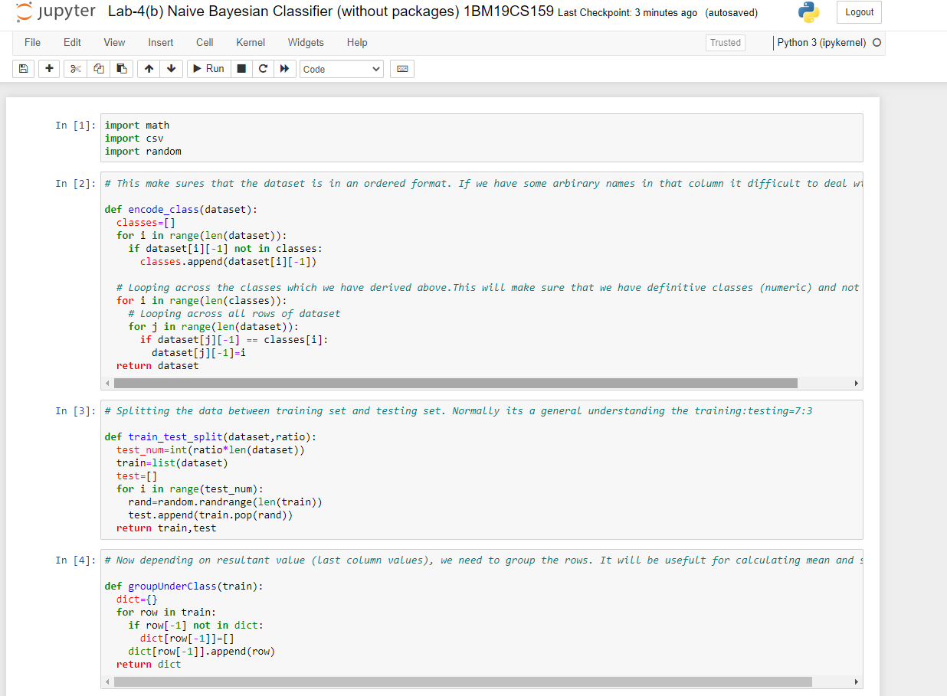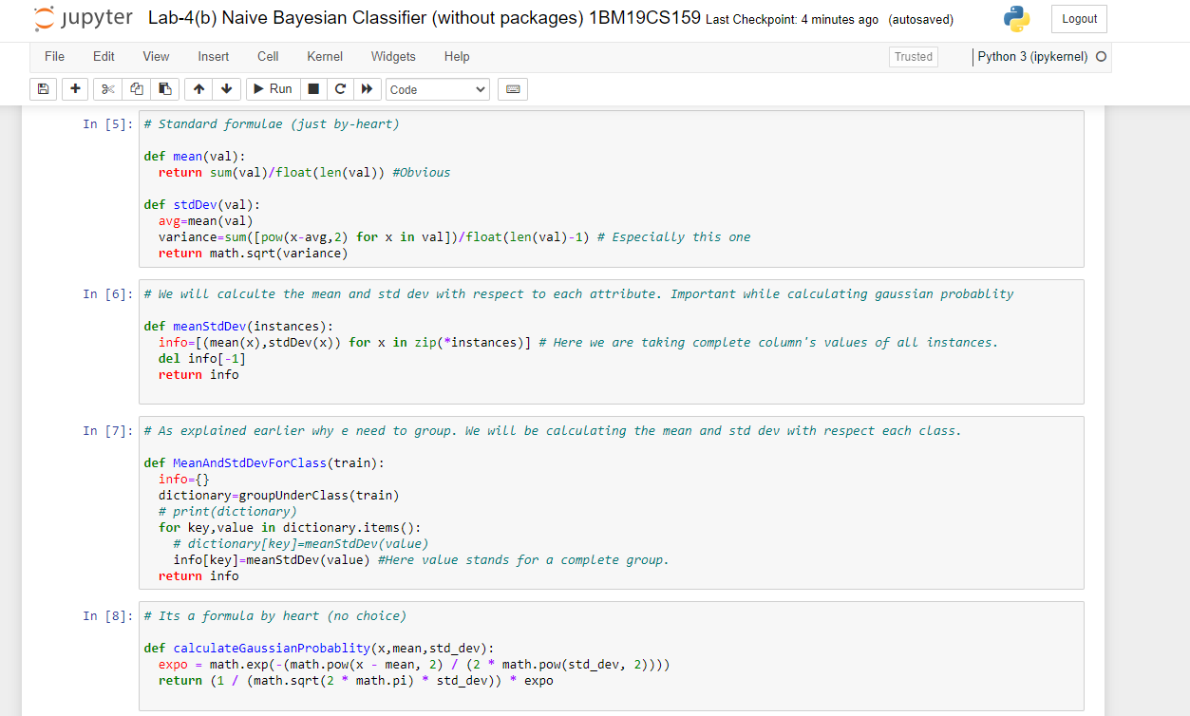

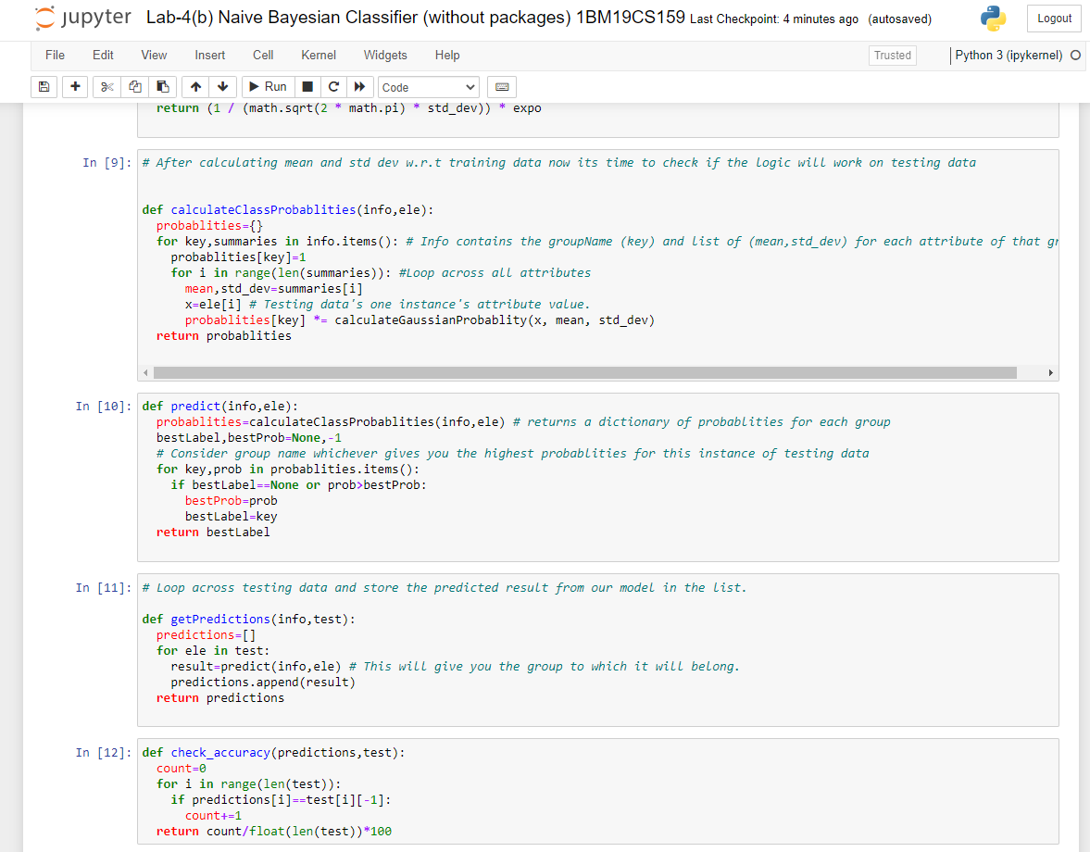 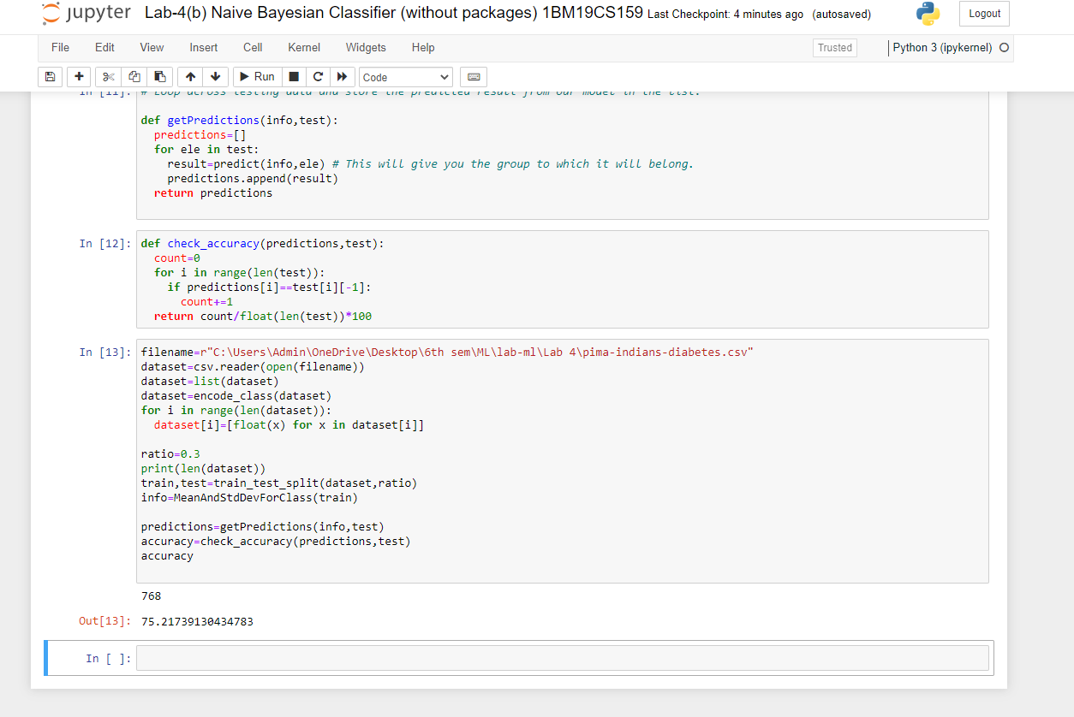

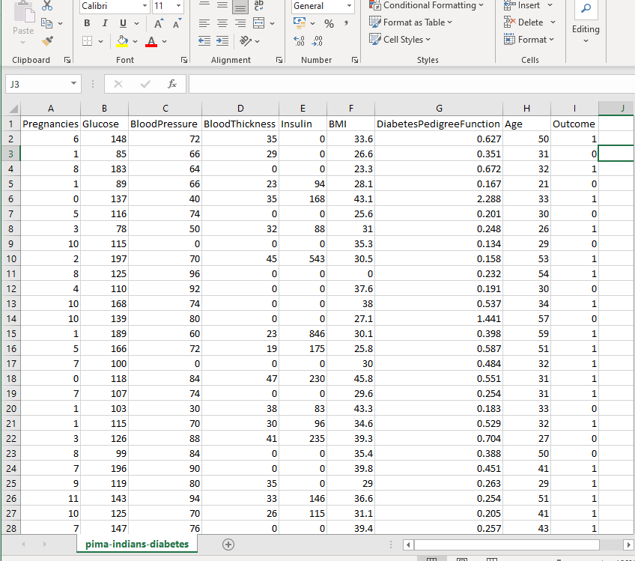

**Lab Program -5.:-**

Implement the Linear Regression algorithm in order to fit data points. Select appropriate data set for your experiment and draw graphs.

***Source code and output :-***

+*In[1]:*+

[source, ipython3]

----

import numpy as np

import matplotlib.pyplot as plt

import pandas as pd

----

+*In[11]:*+

[source, ipython3]

----

dataset = pd.read_csv(r"C:\Users\Admin\OneDrive\Desktop\6th sem\ML\lab-ml\Lab 5\Lr-Salary Dataset.csv")

X = dataset.iloc[:, :-1].values

y = dataset.iloc[:, 1].values

----

+*In[13]:*+

[source, ipython3]

----

from sklearn.model_selection import train_test_split

X_train, X_test, y_train, y_test = train_test_split(X, y, test_size=1/3, random_state=0)

----

+*In[14]:*+

[source, ipython3]

----

# Fitting Simple Linear Regression to the Training set

from sklearn.linear_model import LinearRegression

regressor = LinearRegression()

regressor.fit(X_train, y_train)

----

+*Out[14]:*+

----LinearRegression()----

+*In[15]:*+

[source, ipython3]

----

# Predicting the Test set results

y_pred = regressor.predict(X_test)

----

+*In[19]:*+

[source, ipython3]

----

# Visualizing the Training set results

viz_train = plt

viz_train.scatter(X_train, y_train, color='red')

viz_train.plot(X_train, regressor.predict(X_train), color='blue')

viz_train.title('Salary VS Experience (Training set)')

viz_train.xlabel('Year of Experience')

viz_train.ylabel('Salary')

viz_train.show()

----

+*Out[19]:*+

----

![png](output_5_0.png)

----

+*In[17]:*+

[source, ipython3]

----

# Visualizing the Test set results

viz_test = plt

viz_test.scatter(X_test, y_test, color='red')

viz_test.plot(X_train, regressor.predict(X_train), color='blue')

viz_test.title('Salary VS Experience (Test set)')

viz_test.xlabel('Year of Experience')

viz_test.ylabel('Salary')

viz_test.show()

----

+*Out[17]:*+

----

![png](output_6_0.png)

----

+*In[ ]:*+

[source, ipython3]

----

----

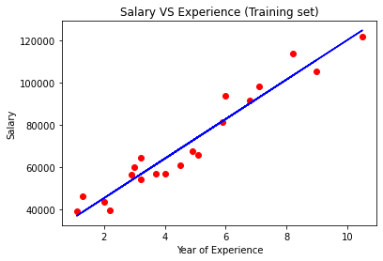

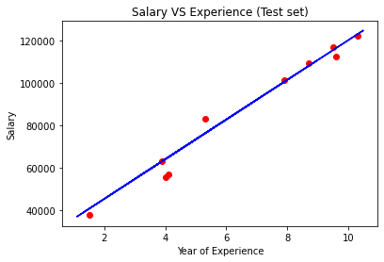

***Output screenshots :-***

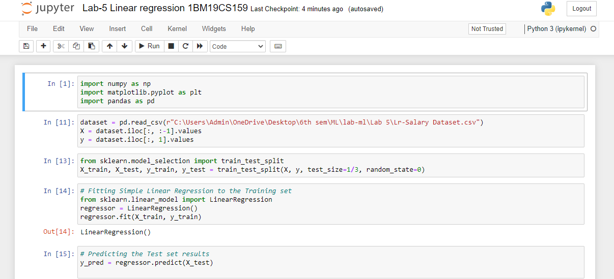

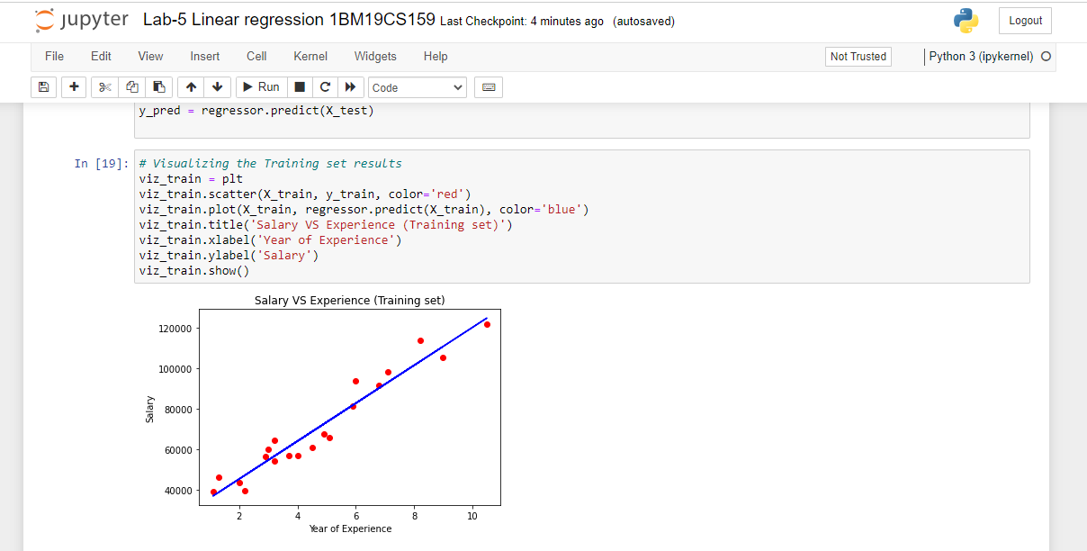

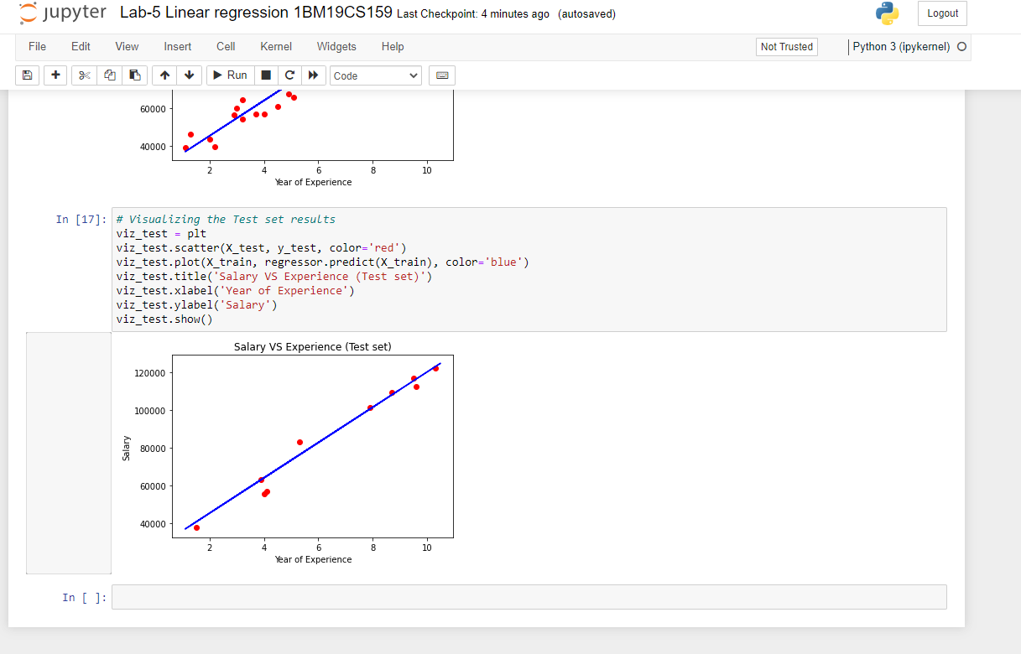

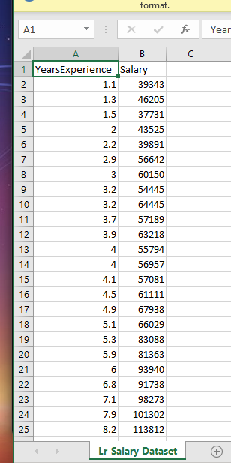

**Lab Program -6 :-**

Write a program to construct a Bayesian network considering training data. Use this model to make predictions.

***Source code and output :-***

+*In[1]:*+

[source, ipython3]

----

!pip install pgmpy

----

+*Out[1]:*+

----

Defaulting to user installation because normal site-packages is not writeable

Collecting pgmpy

Downloading pgmpy-0.1.18-py3-none-any.whl (1.9 MB)

Requirement already satisfied: scipy in c:\programdata\anaconda3\lib\site-packages (from pgmpy) (1.7.3)

Requirement already satisfied: pyparsing in c:\programdata\anaconda3\lib\site-packages (from pgmpy) (3.0.4)

Requirement already satisfied: pandas in c:\programdata\anaconda3\lib\site-packages (from pgmpy) (1.4.2)

Collecting torch

Downloading torch-1.11.0-cp39-cp39-win_amd64.whl (157.9 MB)

Requirement already satisfied: scikit-learn in c:\programdata\anaconda3\lib\site-packages (from pgmpy) (1.0.2)

Requirement already satisfied: numpy in c:\programdata\anaconda3\lib\site-packages (from pgmpy) (1.21.5)

Requirement already satisfied: tqdm in c:\programdata\anaconda3\lib\site-packages (from pgmpy) (4.64.0)

Requirement already satisfied: networkx in c:\programdata\anaconda3\lib\site-packages (from pgmpy) (2.7.1)

Requirement already satisfied: joblib in c:\programdata\anaconda3\lib\site-packages (from pgmpy) (1.1.0)

Requirement already satisfied: statsmodels in c:\programdata\anaconda3\lib\site-packages (from pgmpy) (0.13.2)

Requirement already satisfied: python-dateutil>=2.8.1 in c:\programdata\anaconda3\lib\site-packages (from pandas->pgmpy) (2.8.2)

Requirement already satisfied: pytz>=2020.1 in c:\programdata\anaconda3\lib\site-packages (from pandas->pgmpy) (2021.3)

Requirement already satisfied: six>=1.5 in c:\programdata\anaconda3\lib\site-packages (from python-dateutil>=2.8.1->pandas->pgmpy) (1.16.0)

Requirement already satisfied: threadpoolctl>=2.0.0 in c:\programdata\anaconda3\lib\site-packages (from scikit-learn->pgmpy) (2.2.0)

Requirement already satisfied: patsy>=0.5.2 in c:\programdata\anaconda3\lib\site-packages (from statsmodels->pgmpy) (0.5.2)

Requirement already satisfied: packaging>=21.3 in c:\programdata\anaconda3\lib\site-packages (from statsmodels->pgmpy) (21.3)

Requirement already satisfied: typing-extensions in c:\programdata\anaconda3\lib\site-packages (from torch->pgmpy) (4.1.1)

Requirement already satisfied: colorama in c:\programdata\anaconda3\lib\site-packages (from tqdm->pgmpy) (0.4.4)

Installing collected packages: torch, pgmpy

Successfully installed pgmpy-0.1.18 torch-1.11.0

WARNING: The scripts convert-caffe2-to-onnx.exe, convert-onnx-to-caffe2.exe and torchrun.exe are installed in 'C:\Users\Admin\AppData\Roaming\Python\Python39\Scripts' which is not on PATH.

Consider adding this directory to PATH or, if you prefer to suppress this warning, use --no-warn-script-location.

----

+*In[1]:*+

[source, ipython3]

----

import numpy as np

import pandas as pd

import csv

import pgmpy

from pgmpy.estimators import MaximumLikelihoodEstimator

from pgmpy.models import BayesianModel

from pgmpy.inference import VariableElimination

----

+*In[6]:*+

[source, ipython3]

----

#read Cleveland Heart Disease data

heartDisease = pd.read_csv(r'C:\Users\Admin\OneDrive\Desktop\6th sem\ML\lab-ml\Lab 6\heart.csv')

heartDisease = heartDisease.replace('?',np.nan)

----

+*In[7]:*+

[source, ipython3]

----

#display the data

print('Sample instances from the dataset are given below')

print(heartDisease.head())

----

+*Out[7]:*+

----

Sample instances from the dataset are given below

Unnamed: 0 age sex cp trestbps chol fbs restecg thalach exang \

0 NaN 63.0 1.0 1.0 145.0 233.0 1.0 2.0 150.0 0.0

1 NaN 67.0 1.0 4.0 160.0 286.0 0.0 2.0 108.0 1.0

2 NaN 67.0 1.0 4.0 120.0 229.0 0.0 2.0 129.0 1.0

3 NaN 37.0 1.0 3.0 130.0 250.0 0.0 0.0 187.0 0.0

4 NaN 41.0 0.0 2.0 130.0 204.0 0.0 2.0 172.0 0.0

... slope ca thal heartdisease Unnamed: 15 Unnamed: 16 Unnamed: 17 \

0 ... 3.0 0 6 0.0 NaN NaN NaN

1 ... 2.0 3 3 2.0 NaN NaN NaN

2 ... 2.0 2 7 1.0 NaN NaN NaN

3 ... 3.0 0 3 0.0 NaN NaN NaN

4 ... 1.0 0 3 0.0 NaN NaN NaN

Unnamed: 18 Unnamed: 19 Unnamed: 20

0 NaN NaN NaN

1 NaN NaN NaN

2 NaN NaN NaN

3 NaN NaN NaN

4 NaN NaN NaN

[5 rows x 21 columns]

----

+*In[8]:*+

[source, ipython3]

----

#display the Attributes names and datatyes

print('\n Attributes and datatypes')

print(heartDisease.dtypes)

----

+*Out[8]:*+

----

Attributes and datatypes

Unnamed: 0 float64

age float64

sex float64

cp float64

trestbps float64

chol float64

fbs float64

restecg float64

thalach float64

exang float64

oldpeak float64

slope float64

ca object

thal object

heartdisease float64

Unnamed: 15 float64

Unnamed: 16 float64

Unnamed: 17 float64

Unnamed: 18 float64

Unnamed: 19 float64

Unnamed: 20 float64

dtype: object

----

+*In[9]:*+

[source, ipython3]

----

#Creat Model-Bayesian Network

model = BayesianModel([('age','heartdisease'),('sex','heartdisease'),('exang','heartdisease'),('cp','heartdisease'),('heartdisease','restecg'),('heartdisease','chol')])

----

+*Out[9]:*+

----

C:\Users\Admin\AppData\Roaming\Python\Python39\site-packages\pgmpy\models\BayesianModel.py:8: FutureWarning: BayesianModel has been renamed to BayesianNetwork. Please use BayesianNetwork class, BayesianModel will be removed in future.

warnings.warn(

----

+*In[10]:*+

[source, ipython3]

----

#Learning CPDs using Maximum Likelihood Estimators

print('\n Learning CPD using Maximum likelihood estimators')

model.fit(heartDisease,estimator=MaximumLikelihoodEstimator)

----

+*Out[10]:*+

----

Learning CPD using Maximum likelihood estimators

----

+*In[11]:*+

[source, ipython3]

----

#Inferencing with Bayesian Network

print('\n Inferencing with Bayesian Network:')

HeartDiseasetest_infer = VariableElimination(model)

----

+*Out[11]:*+

----

Inferencing with Bayesian Network:

----

+*In[12]:*+

[source, ipython3]

----

#computing the Probability of HeartDisease given restecg

print('\n 1.Probability of HeartDisease given evidence= restecg :1')

q1=HeartDiseasetest_infer.query(variables=['heartdisease'],evidence={'restecg':1})

print(q1)

----

+*Out[12]:*+

----

1.Probability of HeartDisease given evidence= restecg :1

0%| | 0/4 [00:00<?, ?it/s] 0%| | 0/4 [00:00<?, ?it/s]

+-------------------+---------------------+

| heartdisease | phi(heartdisease) |

+===================+=====================+

| heartdisease(0.0) | 0.2000 |

+-------------------+---------------------+

| heartdisease(1.0) | 0.2000 |

+-------------------+---------------------+

| heartdisease(2.0) | 0.2000 |

+-------------------+---------------------+

| heartdisease(3.0) | 0.2000 |

+-------------------+---------------------+

| heartdisease(4.0) | 0.2000 |

+-------------------+---------------------+

----

+*In[14]:*+

[source, ipython3]

----

#computing the Probability of HeartDisease given cp

print('\n 2.Probability of HeartDisease given evidence= cp:2 ')

q2=HeartDiseasetest_infer.query(variables=['heartdisease'],evidence={'cp':2})

print(q2)

----

+*Out[14]:*+

----

2.Probability of HeartDisease given evidence= cp:2

0%| | 0/3 [00:00<?, ?it/s] 0%| | 0/3 [00:00<?, ?it/s]

+-------------------+---------------------+

| heartdisease | phi(heartdisease) |

+===================+=====================+

| heartdisease(0.0) | 0.2000 |

+-------------------+---------------------+

| heartdisease(1.0) | 0.2000 |

+-------------------+---------------------+

| heartdisease(2.0) | 0.2000 |

+-------------------+---------------------+

| heartdisease(3.0) | 0.2000 |

+-------------------+---------------------+

| heartdisease(4.0) | 0.2000 |

+-------------------+---------------------+

----

+*In[ ]:*+

[source, ipython3]

----

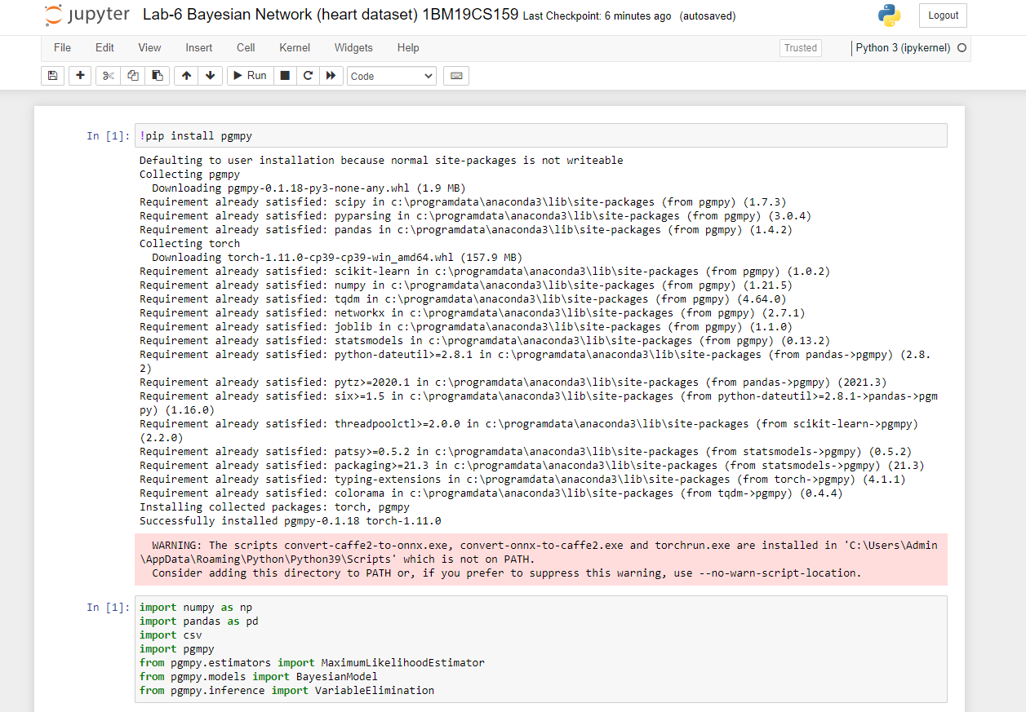

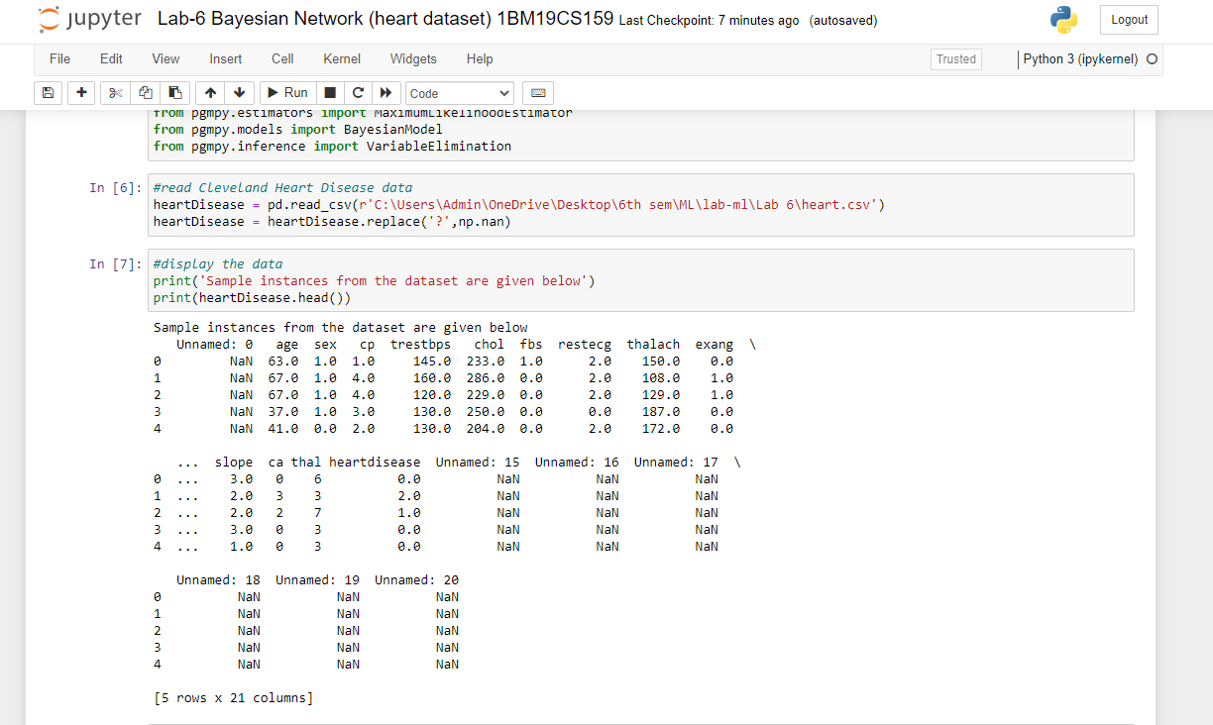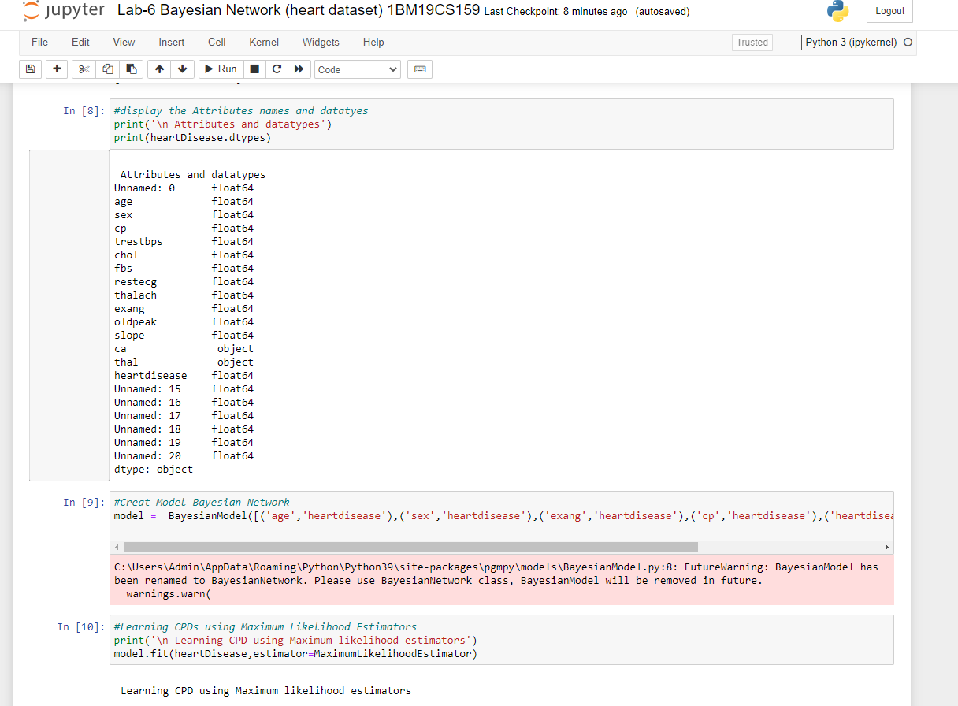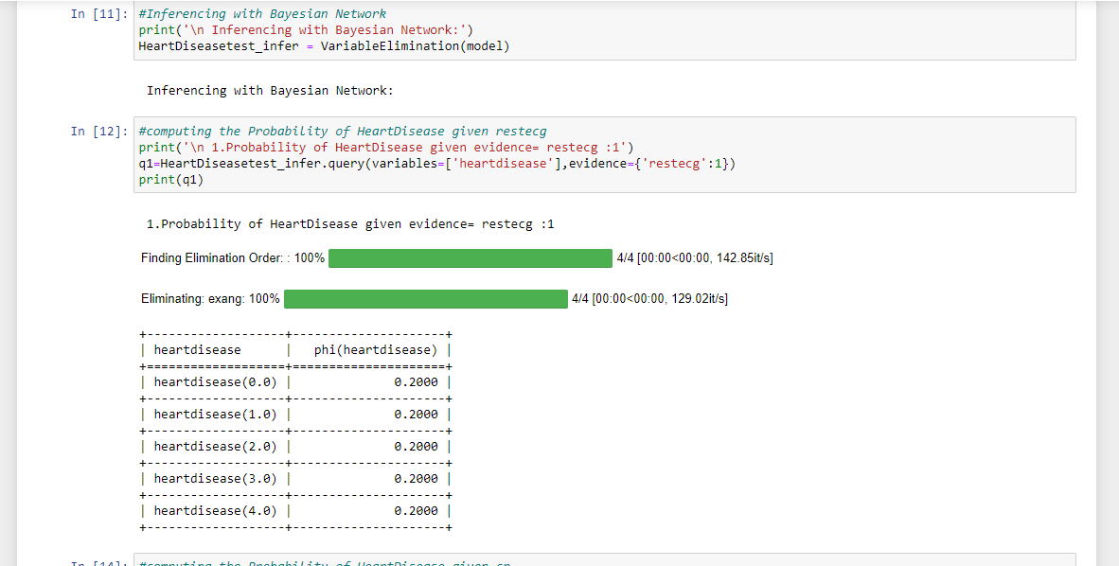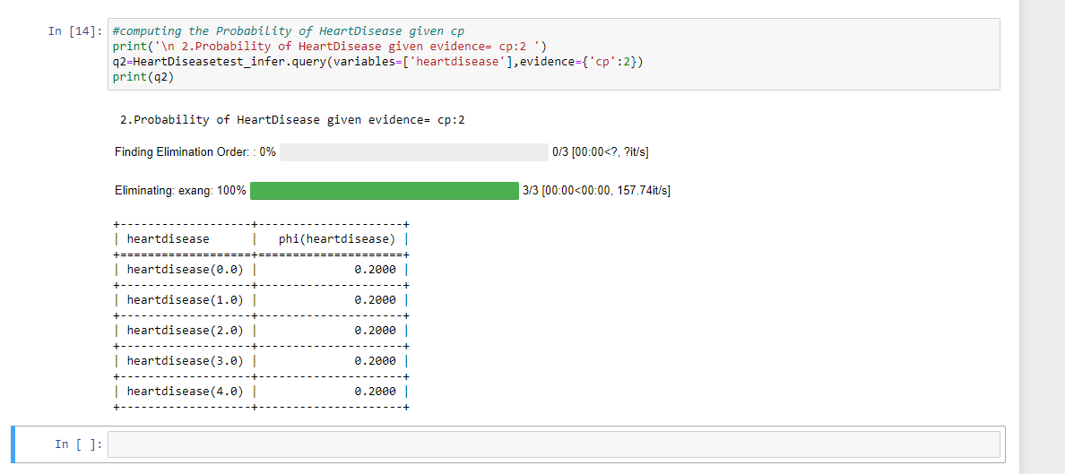

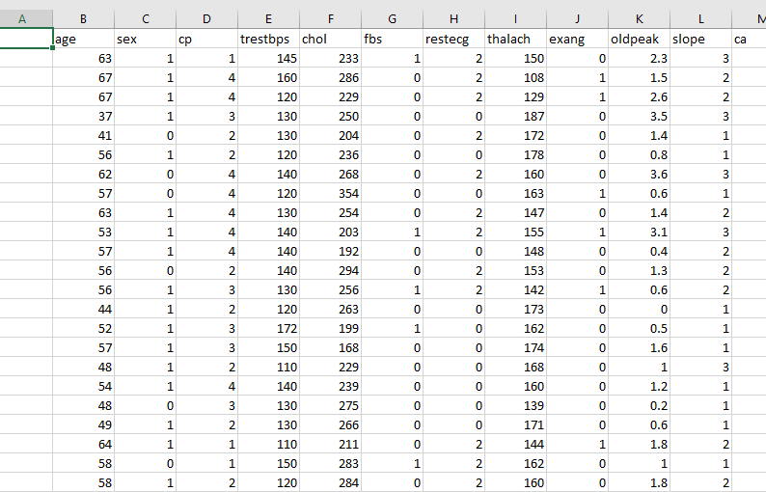

**Lab Program -7 :-**

Apply k-Means algorithm to cluster a set of data stored in a .CSV file.

***Source code and output :-***

#!/usr/bin/env python

# coding: utf-8

# In[18]:

import pandas as pd

import matplotlib

import numpy as np

import matplotlib.pyplot as plt

from sklearn.cluster import KMeans

from sklearn.preprocessing import MinMaxScaler

from matplotlib import pyplot as plt

get_ipython().run_line_magic('matplotlib', 'inline')

# In[19]:

df = pd.read_csv(r'C:\Users\Admin\OneDrive\Desktop\6th sem\ML\lab-ml\Lab 7\income.csv')

df.head(10)

# In[20]:

scaler = MinMaxScaler()

scaler.fit(df[['Age']])

df[['Age']] = scaler.transform(df[['Age']])

scaler.fit(df[['Income($)']])

df[['Income($)']] = scaler.transform(df[['Income($)']])

df.head(10)

# In[21]:

plt.scatter(df['Age'], df['Income($)'])

# In[22]:

k_range = range(1, 11)

sse = []

for k in k_range:

kmc = KMeans(n_clusters=k)

kmc.fit(df[['Age', 'Income($)']])

sse.append(kmc.inertia_)

sse

# In[23]:

plt.xlabel = 'Number of Clusters'

plt.ylabel = 'Sum of Squared Errors'

plt.plot(k_range, sse)

Therefore, the elbow point is 3

# In[24]:

km = KMeans(n_clusters=3)

km

# In[25]:

y_predict = km.fit_predict(df[['Age', 'Income($)']])

y_predict

# In[26]:

df['cluster'] = y_predict

df.head()

# In[27]:

df0 = df[df.cluster == 0]

df0

# In[28]:

df1 = df[df.cluster == 1]

df1

# In[29]:

df2 = df[df.cluster == 2]

df2

# In[30]:

km.cluster_centers_

# In[34]:

p1 = plt.scatter(df0['Age'], df0['Income($)'], marker='+', color='red')

p2 = plt.scatter(df1['Age'], df1['Income($)'], marker='*', color='blue')

p3 = plt.scatter(df2['Age'], df2['Income($)'], marker='^', color='green')

c = plt.scatter(km.cluster_centers_[:,0], km.cluster_centers_[:,1], color='black')

plt.legend((p1, p2, p3, c),

('Cluster 1', 'Cluster 2', 'Cluster 3', 'Centroid'))

# In[ ]: 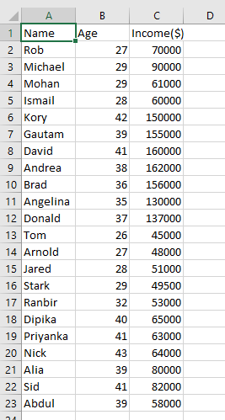

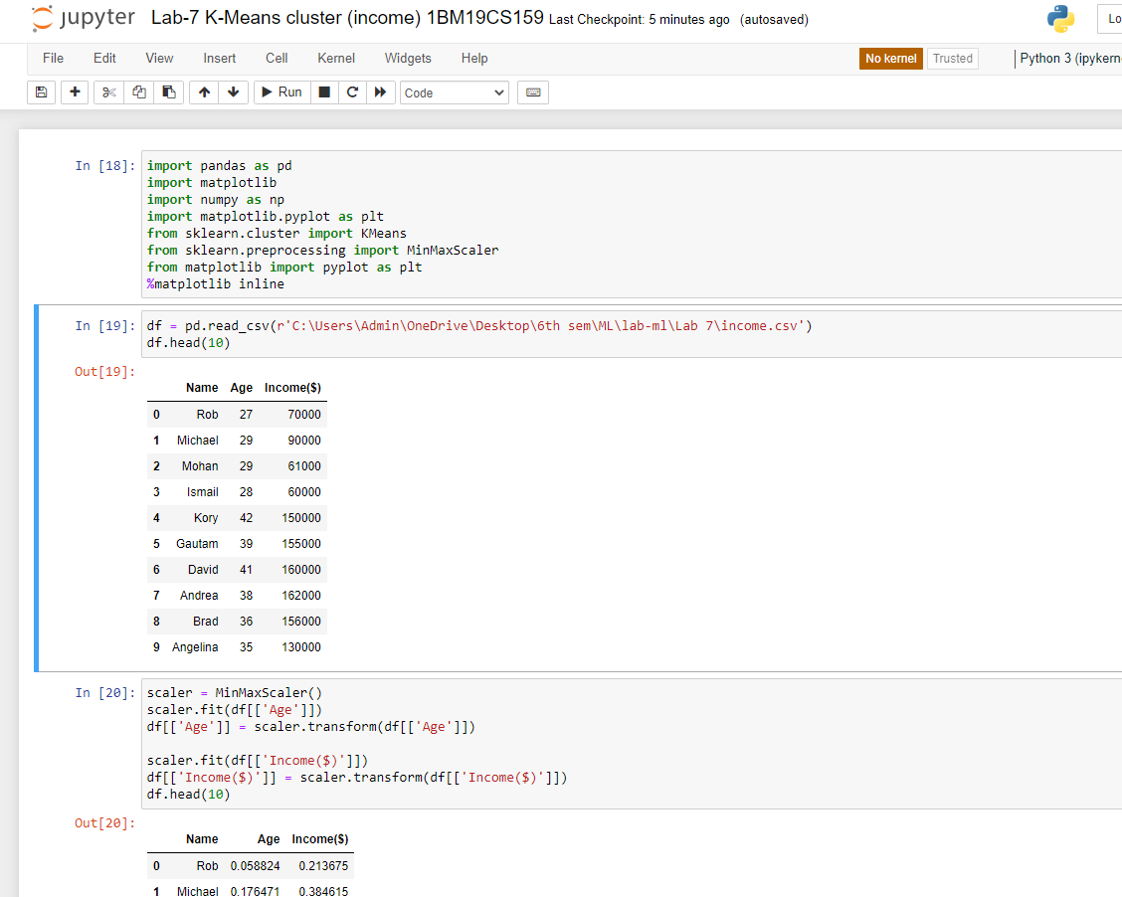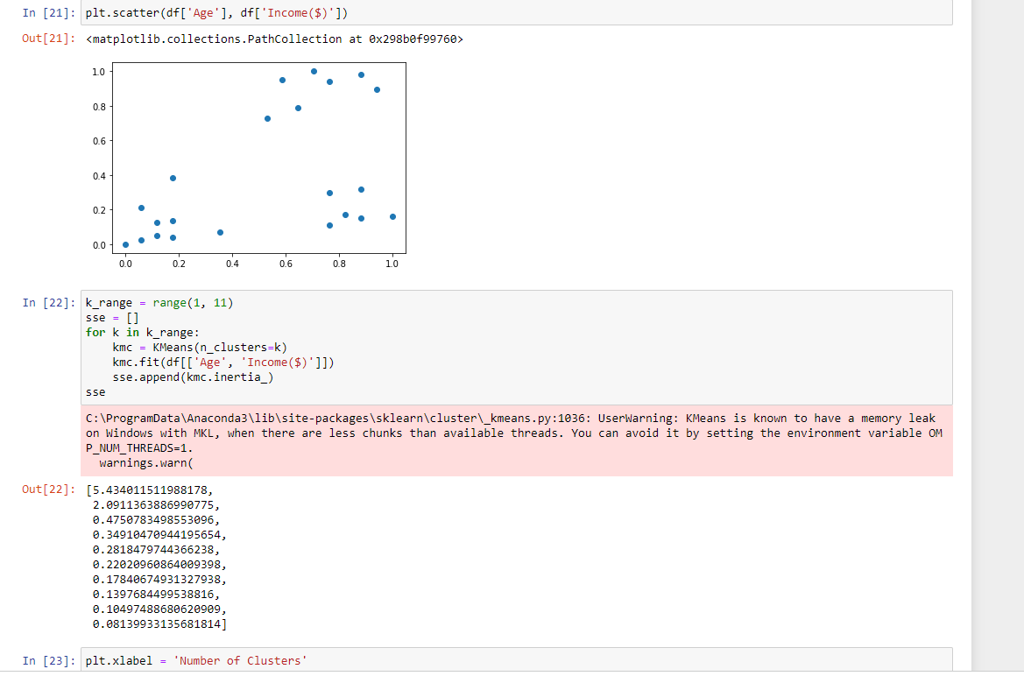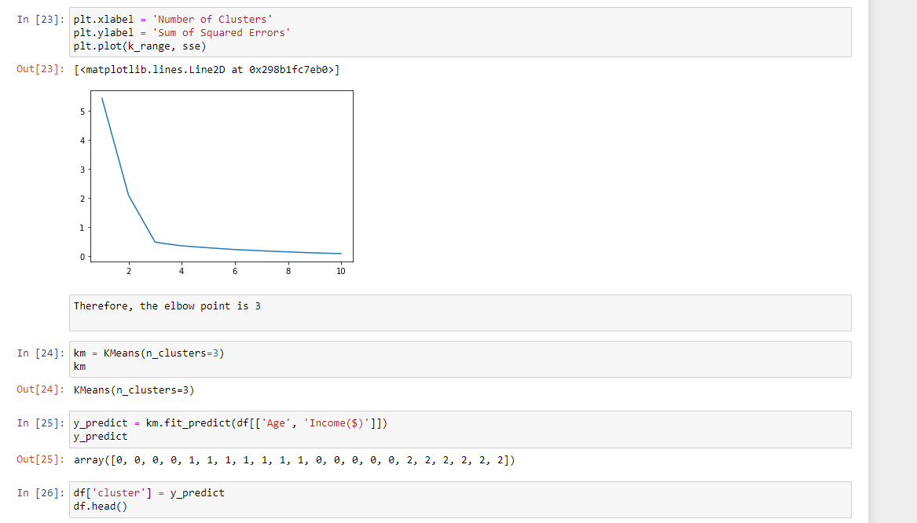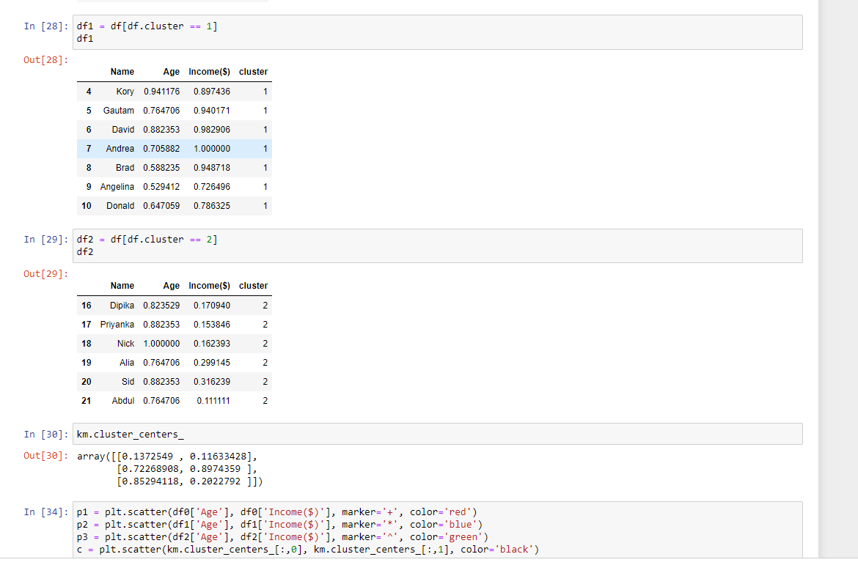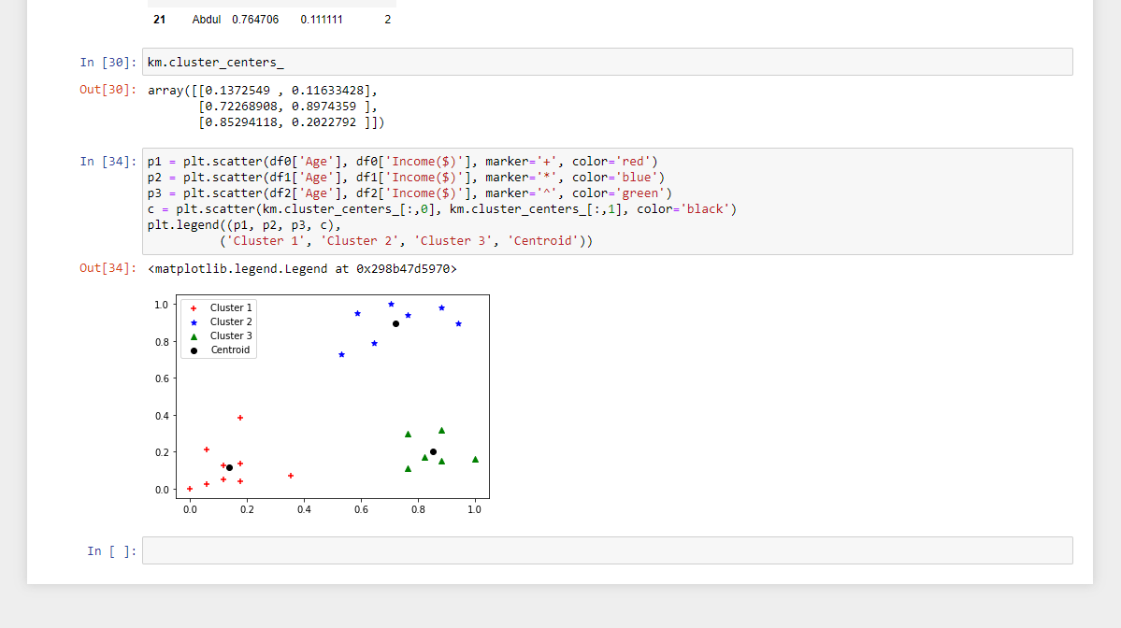

**Lab Program -8 :-**

Apply EM algorithm to cluster a set of data stored in a .CSV file. Compare the results of k-Means algorithm and EM algorithm.

***Source code and output :-***

+*In[1]:*+

[source, ipython3]

----

import matplotlib.pyplot as plt

from sklearn import datasets

from sklearn.cluster import KMeans

import sklearn.metrics as sm

import pandas as pd

import numpy as np

iris = datasets.load_iris()

X = pd.DataFrame(iris.data)

X.columns = ['Sepal_Length','Sepal_Width','Petal_Length','Petal_Width']

y = pd.DataFrame(iris.target)

y.columns = ['Targets']

model = KMeans(n_clusters=3)

model.fit(X)

plt.figure(figsize=(14,7))

colormap = np.array(['red', 'lime', 'black'])

# Plot the Original Classifications

plt.subplot(1, 2, 1)

plt.scatter(X.Petal_Length, X.Petal_Width, c=colormap[y.Targets], s=40)

plt.title('Real Classification')

plt.xlabel('Petal Length')

plt.ylabel('Petal Width')

# Plot the Models Classifications

plt.subplot(1, 2, 2)

plt.scatter(X.Petal_Length, X.Petal_Width, c=colormap[model.labels_], s=40)

plt.title('K Mean Classification')

plt.xlabel('Petal Length')

plt.ylabel('Petal Width')

print('The accuracy score of K-Mean: ',sm.accuracy_score(y, model.labels_))

print('The Confusion matrixof K-Mean: ',sm.confusion_matrix(y, model.labels_))

from sklearn import preprocessing

scaler = preprocessing.StandardScaler()

scaler.fit(X)

xsa = scaler.transform(X)

xs = pd.DataFrame(xsa, columns = X.columns)

#xs.sample(5)

from sklearn.mixture import GaussianMixture

gmm = GaussianMixture(n_components=3)

gmm.fit(xs)

y_gmm = gmm.predict(xs)

#y_cluster_gmm

plt.subplot(2, 2, 3)

plt.scatter(X.Petal_Length, X.Petal_Width, c=colormap[y_gmm], s=40)

plt.title('GMM Classification')

plt.xlabel('Petal Length')

plt.ylabel('Petal Width')

print('The accuracy score of EM: ',sm.accuracy_score(y, y_gmm))

print('The Confusion matrix of EM: ',sm.confusion_matrix(y, y_gmm))

----

+*Out[1]:*+

----

The accuracy score of K-Mean: 0.24

The Confusion matrixof K-Mean: [[ 0 50 0]

[48 0 2]

[14 0 36]]

The accuracy score of EM: 0.35333333333333333

The Confusion matrix of EM: [[ 5 0 45]

[ 2 48 0]

[ 0 50 0]]

![png](output_0_1.png)

----

+*In[ ]:*+

[source, ipython3]

----

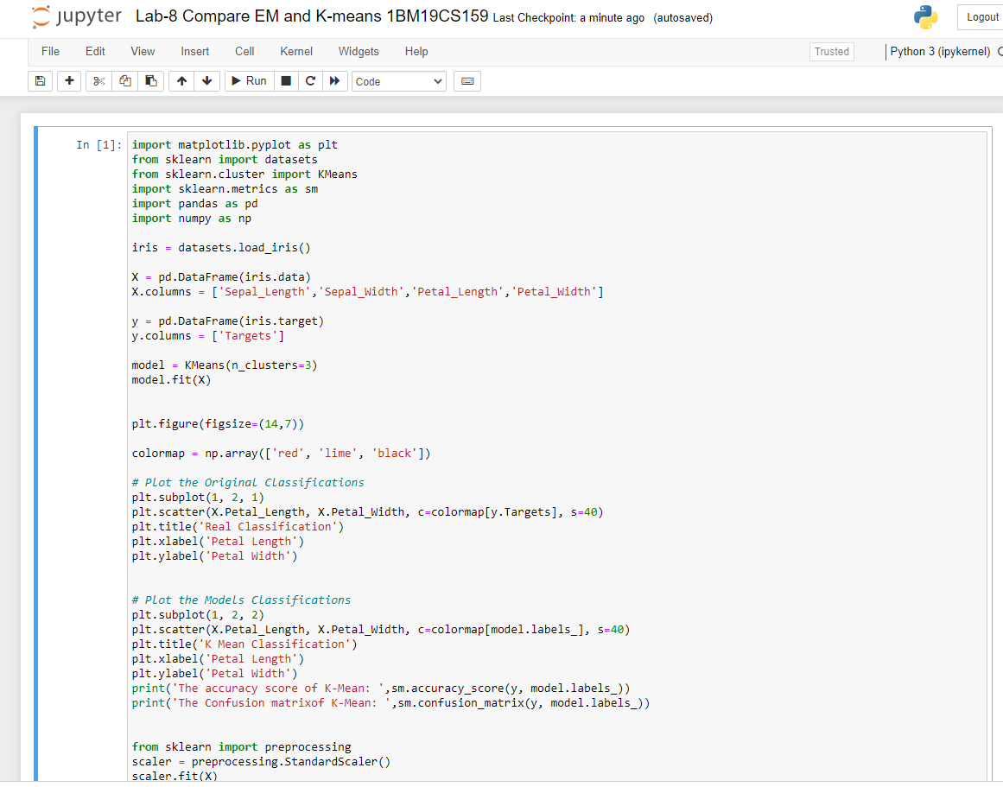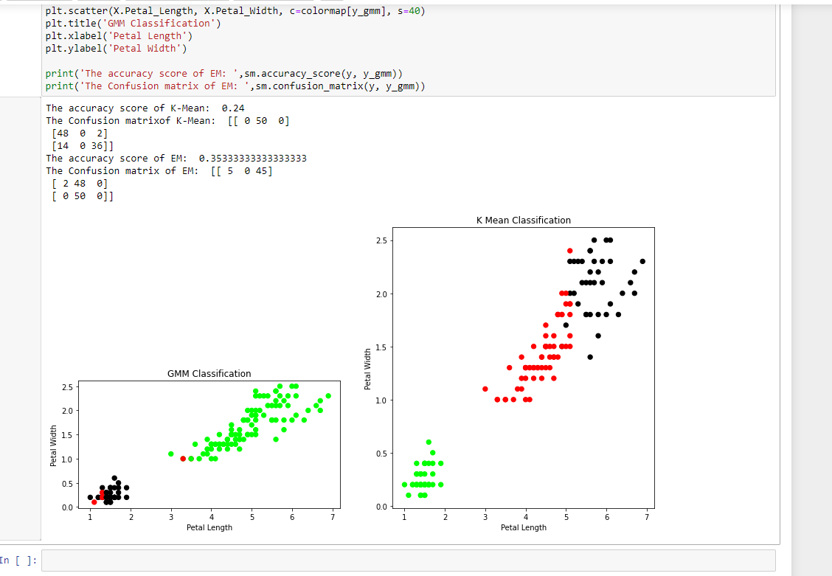

**Lab Program -9:-**

Write a program to implement k-Nearest Neighbour algorithm to classify the iris data set. Print both correct and wrong predictions.

***Source code and output :-***

+*In[1]:*+

[source, ipython3]

----

from sklearn.model_selection import train_test_split

from sklearn.neighbors import KNeighborsClassifier

from sklearn.metrics import classification_report, confusion_matrix

from sklearn import datasets

iris=datasets.load_iris()

x = iris.data

y = iris.target

print ('sepal-length', 'sepal-width', 'petal-length', 'petal-width')

print(x)

print('class: 0-Iris-Setosa, 1- Iris-Versicolour, 2- Iris-Virginica')

print(y)

x_train, x_test, y_train, y_test = train_test_split(x,y,test_size=0.3)

#To Training the model and Nearest nighbors K=5

classifier = KNeighborsClassifier(n_neighbors=5)

classifier.fit(x_train, y_train)

#To make predictions on our test data

y_pred=classifier.predict(x_test)

print('Confusion Matrix')

print(confusion_matrix(y_test,y_pred))

print('Accuracy Metrics')

print(classification_report(y_test,y_pred))

----

+*Out[1]:*+

----

sepal-length sepal-width petal-length petal-width

[[5.1 3.5 1.4 0.2]

[4.9 3. 1.4 0.2]

[4.7 3.2 1.3 0.2]

[4.6 3.1 1.5 0.2]

[5. 3.6 1.4 0.2]

[5.4 3.9 1.7 0.4]

[4.6 3.4 1.4 0.3]

[5. 3.4 1.5 0.2]

[4.4 2.9 1.4 0.2]

[4.9 3.1 1.5 0.1]

[5.4 3.7 1.5 0.2]

[4.8 3.4 1.6 0.2]

[4.8 3. 1.4 0.1]

[4.3 3. 1.1 0.1]

[5.8 4. 1.2 0.2]

[5.7 4.4 1.5 0.4]

[5.4 3.9 1.3 0.4]

[5.1 3.5 1.4 0.3]

[5.7 3.8 1.7 0.3]

[5.1 3.8 1.5 0.3]

[5.4 3.4 1.7 0.2]

[5.1 3.7 1.5 0.4]

[4.6 3.6 1. 0.2]

[5.1 3.3 1.7 0.5]

[4.8 3.4 1.9 0.2]

[5. 3. 1.6 0.2]

[5. 3.4 1.6 0.4]

[5.2 3.5 1.5 0.2]

[5.2 3.4 1.4 0.2]

[4.7 3.2 1.6 0.2]

[4.8 3.1 1.6 0.2]

[5.4 3.4 1.5 0.4]

[5.2 4.1 1.5 0.1]

[5.5 4.2 1.4 0.2]

[4.9 3.1 1.5 0.2]

[5. 3.2 1.2 0.2]

[5.5 3.5 1.3 0.2]

[4.9 3.6 1.4 0.1]

[4.4 3. 1.3 0.2]

[5.1 3.4 1.5 0.2]

[5. 3.5 1.3 0.3]

[4.5 2.3 1.3 0.3]

[4.4 3.2 1.3 0.2]

[5. 3.5 1.6 0.6]

[5.1 3.8 1.9 0.4]

[4.8 3. 1.4 0.3]

[5.1 3.8 1.6 0.2]

[4.6 3.2 1.4 0.2]

[5.3 3.7 1.5 0.2]

[5. 3.3 1.4 0.2]

[7. 3.2 4.7 1.4]

[6.4 3.2 4.5 1.5]

[6.9 3.1 4.9 1.5]

[5.5 2.3 4. 1.3]

[6.5 2.8 4.6 1.5]

[5.7 2.8 4.5 1.3]

[6.3 3.3 4.7 1.6]

[4.9 2.4 3.3 1. ]

[6.6 2.9 4.6 1.3]

[5.2 2.7 3.9 1.4]

[5. 2. 3.5 1. ]

[5.9 3. 4.2 1.5]

[6. 2.2 4. 1. ]

[6.1 2.9 4.7 1.4]

[5.6 2.9 3.6 1.3]

[6.7 3.1 4.4 1.4]

[5.6 3. 4.5 1.5]

[5.8 2.7 4.1 1. ]

[6.2 2.2 4.5 1.5]

[5.6 2.5 3.9 1.1]

[5.9 3.2 4.8 1.8]

[6.1 2.8 4. 1.3]

[6.3 2.5 4.9 1.5]

[6.1 2.8 4.7 1.2]

[6.4 2.9 4.3 1.3]

[6.6 3. 4.4 1.4]

[6.8 2.8 4.8 1.4]

[6.7 3. 5. 1.7]

[6. 2.9 4.5 1.5]

[5.7 2.6 3.5 1. ]

[5.5 2.4 3.8 1.1]

[5.5 2.4 3.7 1. ]

[5.8 2.7 3.9 1.2]

[6. 2.7 5.1 1.6]

[5.4 3. 4.5 1.5]

[6. 3.4 4.5 1.6]

[6.7 3.1 4.7 1.5]

[6.3 2.3 4.4 1.3]

[5.6 3. 4.1 1.3]

[5.5 2.5 4. 1.3]

[5.5 2.6 4.4 1.2]

[6.1 3. 4.6 1.4]

[5.8 2.6 4. 1.2]

[5. 2.3 3.3 1. ]

[5.6 2.7 4.2 1.3]

[5.7 3. 4.2 1.2]

[5.7 2.9 4.2 1.3]

[6.2 2.9 4.3 1.3]

[5.1 2.5 3. 1.1]

[5.7 2.8 4.1 1.3]

[6.3 3.3 6. 2.5]

[5.8 2.7 5.1 1.9]

[7.1 3. 5.9 2.1]

[6.3 2.9 5.6 1.8]

[6.5 3. 5.8 2.2]

[7.6 3. 6.6 2.1]

[4.9 2.5 4.5 1.7]

[7.3 2.9 6.3 1.8]

[6.7 2.5 5.8 1.8]

[7.2 3.6 6.1 2.5]

[6.5 3.2 5.1 2. ]

[6.4 2.7 5.3 1.9]

[6.8 3. 5.5 2.1]

[5.7 2.5 5. 2. ]

[5.8 2.8 5.1 2.4]

[6.4 3.2 5.3 2.3]

[6.5 3. 5.5 1.8]

[7.7 3.8 6.7 2.2]

[7.7 2.6 6.9 2.3]

[6. 2.2 5. 1.5]

[6.9 3.2 5.7 2.3]

[5.6 2.8 4.9 2. ]

[7.7 2.8 6.7 2. ]

[6.3 2.7 4.9 1.8]

[6.7 3.3 5.7 2.1]

[7.2 3.2 6. 1.8]

[6.2 2.8 4.8 1.8]

[6.1 3. 4.9 1.8]

[6.4 2.8 5.6 2.1]

[7.2 3. 5.8 1.6]

[7.4 2.8 6.1 1.9]

[7.9 3.8 6.4 2. ]

[6.4 2.8 5.6 2.2]

[6.3 2.8 5.1 1.5]

[6.1 2.6 5.6 1.4]

[7.7 3. 6.1 2.3]

[6.3 3.4 5.6 2.4]

[6.4 3.1 5.5 1.8]

[6. 3. 4.8 1.8]

[6.9 3.1 5.4 2.1]

[6.7 3.1 5.6 2.4]

[6.9 3.1 5.1 2.3]

[5.8 2.7 5.1 1.9]

[6.8 3.2 5.9 2.3]

[6.7 3.3 5.7 2.5]

[6.7 3. 5.2 2.3]

[6.3 2.5 5. 1.9]

[6.5 3. 5.2 2. ]

[6.2 3.4 5.4 2.3]

[5.9 3. 5.1 1.8]]

class: 0-Iris-Setosa, 1- Iris-Versicolour, 2- Iris-Virginica

[0 0 0 0 0 0 0 0 0 0 0 0 0 0 0 0 0 0 0 0 0 0 0 0 0 0 0 0 0 0 0 0 0 0 0 0 0

0 0 0 0 0 0 0 0 0 0 0 0 0 1 1 1 1 1 1 1 1 1 1 1 1 1 1 1 1 1 1 1 1 1 1 1 1

1 1 1 1 1 1 1 1 1 1 1 1 1 1 1 1 1 1 1 1 1 1 1 1 1 1 2 2 2 2 2 2 2 2 2 2 2

2 2 2 2 2 2 2 2 2 2 2 2 2 2 2 2 2 2 2 2 2 2 2 2 2 2 2 2 2 2 2 2 2 2 2 2 2

2 2]

Confusion Matrix

[[12 0 0]

[ 0 14 0]

[ 0 0 19]]

Accuracy Metrics

precision recall f1-score support

0 1.00 1.00 1.00 12

1 1.00 1.00 1.00 14

2 1.00 1.00 1.00 19

accuracy 1.00 45

macro avg 1.00 1.00 1.00 45

weighted avg 1.00 1.00 1.00 45

----

+*In[ ]:*+

[source, ipython3]

----

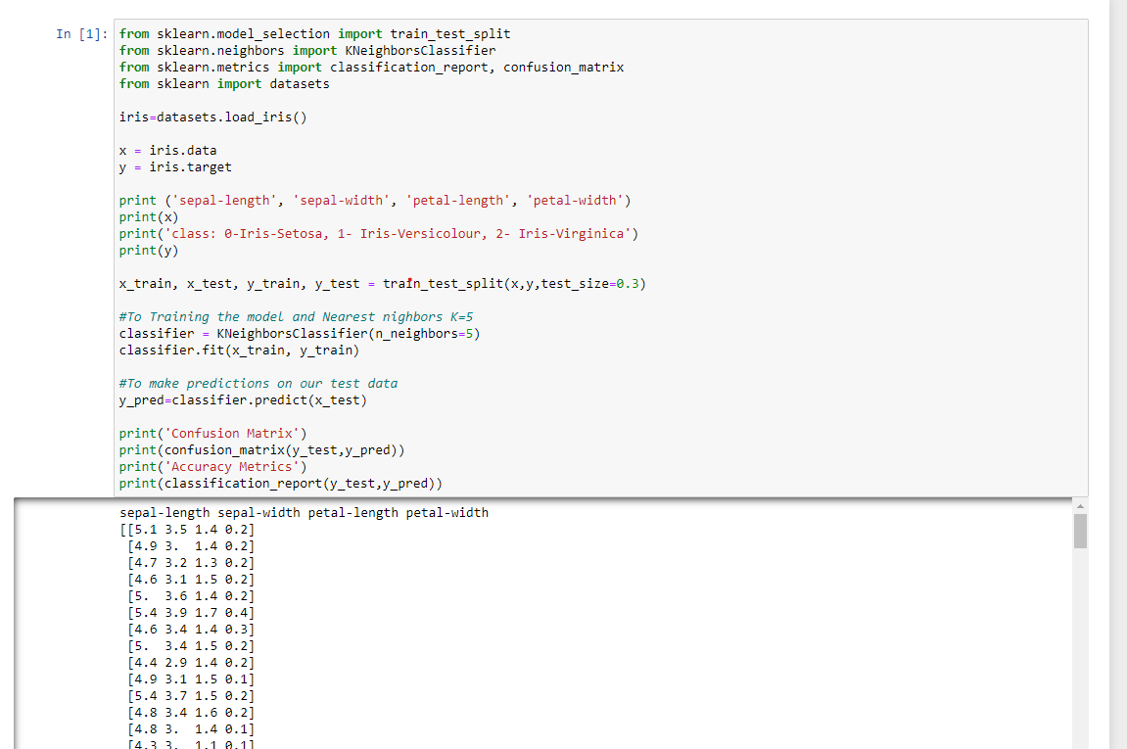

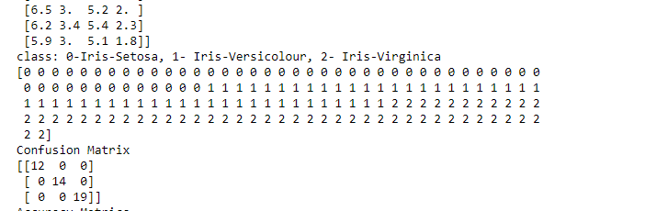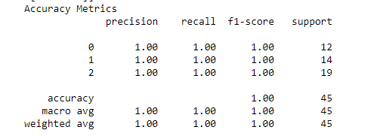

**Lab Program -10 :-**

Implement the non-parametric Locally Weighted Regression algorithm in order to fit data points. Select appropriate data set for your experiment and draw graphs.

***Source code and output :-***

+*In[2]:*+

[source, ipython3]

----

import numpy as np

from bokeh.plotting import figure, show, output_notebook

from bokeh.layouts import gridplot

from bokeh.io import push_notebook

from matplotlib import pyplot as plt

def local_regression(x0, X, Y, tau):# add bias term

x0 = np.r_[1, x0] # Add one to avoid the loss in information

X = np.c_[np.ones(len(X)), X]

# fit model: normal equations with kernel

xw = X.T * radial_kernel(x0, X, tau) # XTranspose * W

beta = np.linalg.pinv(xw @ X) @ xw @ Y #@ Matrix Multiplication or Dot Product

# predict value

return x0 @ beta # @ Matrix Multiplication or Dot Product for prediction

def radial_kernel(x0, X, tau):

return np.exp(np.sum((X - x0) ** 2, axis=1) / (-2 * tau * tau))

# Weight or Radial Kernal Bias Function

n = 1000

# generate dataset

X = np.linspace(-3, 3, num=n)

print("The Data Set ( 10 Samples) X :\n",X[1:10])

Y = np.log(np.abs(X ** 2 - 1) + .5)

print("The Fitting Curve Data Set (10 Samples) Y :\n",Y[1:10])

# jitter X

X += np.random.normal(scale=.1, size=n)

print("Normalised (10 Samples) X :\n",X[1:10])

domain = np.linspace(-3, 3, num=300)

print(" Xo Domain Space(10 Samples) :\n",domain[1:10])

def plot_lwr(tau):

# prediction through regression

prediction = [local_regression(x0, X, Y, tau) for x0 in domain]

plot = figure(plot_width=400, plot_height=400)

plot.title.text='tau=%g' % tau

plot.scatter(X, Y, alpha=.3)

plot.line(domain, prediction, line_width=2, color='red')

return plot

show(gridplot([

[plot_lwr(10.), plot_lwr(1.)],

[plot_lwr(0.1), plot_lwr(0.01)]]))

plt.title('K Mean Classification')

plt.xlabel('Petal Length')

----

+*Out[2]:*+

----

The Data Set ( 10 Samples) X :

[-2.99399399 -2.98798799 -2.98198198 -2.97597598 -2.96996997 -2.96396396

-2.95795796 -2.95195195 -2.94594595]

The Fitting Curve Data Set (10 Samples) Y :

[2.13582188 2.13156806 2.12730467 2.12303166 2.11874898 2.11445659

2.11015444 2.10584249 2.10152068]

Normalised (10 Samples) X :

[-2.88440998 -2.97461063 -2.97639127 -2.9042727 -3.1194782 -3.06506157

-2.8349021 -2.90676221 -2.92454458]

Xo Domain Space(10 Samples) :

[-2.97993311 -2.95986622 -2.93979933 -2.91973244 -2.89966555 -2.87959866

-2.85953177 -2.83946488 -2.81939799]

Text(0.5, 0, 'Petal Length')

![png](output_0_2.png)

----

+*In[3]:*+

[source, ipython3]

----

import matplotlib.pyplot as plt

import pandas as pd

import numpy as np

def kernel(point,xmat, k):

m,n = np.shape(xmat)

weights = np.mat(np.eye((m))) # eye - identity matrix

for j in range(m):

diff = point - X[j]

weights[j,j] = np.exp(diff*diff.T/(-2.0*k**2))

return weights

def localWeight(point,xmat,ymat,k):

wei = kernel(point,xmat,k)

W = (X.T*(wei*X)).I*(X.T*(wei*ymat.T))

return W

def localWeightRegression(xmat,ymat,k):

m,n = np.shape(xmat)

ypred = np.zeros(m)

for i in range(m):

ypred[i] = xmat[i]*localWeight(xmat[i],xmat,ymat,k)

return ypred

def graphPlot(X,ypred):

sortindex = X[:,1].argsort(0) #argsort - index of the smallest

xsort = X[sortindex][:,0]

fig = plt.figure()

ax = fig.add_subplot(1,1,1)

ax.scatter(bill,tip, color='green')

ax.plot(xsort[:,1],ypred[sortindex], color = 'red', linewidth=5)

plt.xlabel('Total bill')

plt.ylabel('Tip')

plt.show();

# load data points

data = pd.read_csv(r'C:\Users\Admin\OneDrive\Desktop\6th sem\ML\lab-ml\Lab 10\tips.csv')

bill = np.array(data.total_bill) # We use only Bill amount and Tips data

tip = np.array(data.tip)

mbill = np.mat(bill) # .mat will convert nd array is converted in 2D array

mtip = np.mat(tip)

m= np.shape(mbill)[1]

one = np.mat(np.ones(m))

X = np.hstack((one.T,mbill.T)) # 244 rows, 2 cols

# increase k to get smooth curves

ypred = localWeightRegression(X,mtip,3)

graphPlot(X,ypred)

----

+*Out[3]:*+

----

![png](output_1_0.png)

----

+*In[ ]:*+

[source, ipython3]

----

